# DEVELOPMENT OF A CELLPHONE CHARGING STATION USING

# PIEZOELECTRIC TECHNOLOGY

A Design Project

Submitted to

The Faculty

Of College of Engineering

University of Perpetual Help System – Jonelta

GMA Campus

In Partial Fulfillment of the

Requirements for the Degree of

Bachelor of Science in Computer Engineering

Researchers

Michael Jerson T. Molines

Lalaine A. Dinglasan

Jeanson S. Ballesteros

Joshua J. Garcia

2018

APPROVAL SHEET

The research project entitled **“DEVELOPMENT OF A CELLPHONE CHARGING STATION USING PIEZOELECTRIC TECHNOLOGY”** prepared and submitted by **Michael Jerson T. Molines, Lalaine A. Dinglasan, Jeanson S. Ballesteros, and Joshua J. Garcia** in partial fulfillment of the requirements for the degree of BACHELOR OF SCIENCE IN COMPUTER ENGINEERING is hereby approved and accepted.

Engineer Rubielyn Punzalan

Adviser

Approved by the committee on oral examination with the grade of ________.

DR. Noel Vargas Engineer William Bucad

Panel Member Panel Member

Dr. Ferdinand Bunag

Panel Member

Accepted and approved in partial fulfillment for the degree of BACHELOR OF SCIENCE IN COMPUTER ENGINEERING.

Dr.Noel H.Vargas

Dean

Date: _____________

Acknowledgements

The researchers would like to express their sincere gratitude to the following people who have supported and assisted in the completion of this study.

To their adviser, Engr. Rubielyn Punzalan for the support and patience to our design project. Thank you for all of the guidance that you have bestowed and helped us to push forward for the exhibit. We are very lucky to have you as our adviser, for our design project would not be possible without your assistance and guidance.

To the panels during, Dr. Ferdinand Bunag, Engr. William Bucad, and Dr. Vargas. Thank you for all of the recommendations and the approval for our design project. We deeply appreciate it.

To Dr. Noel Vargas, department dean, for pushing us to be more efficient and disciplined.

To our families who have never failed to help us we show our deepest gratitude for everything that you have done for us. They are the reason why we are always motivated to accomplish our design project even though there were times that we were financially, emotionally, and mentally challenged. May we someday give back the greatest gift to all of your effort because without them we could not achieve our goal.

To our God for the blessings and hardships that we have encountered along the completion of this study for without the guidance and knowledge from above we could not make until the final in spite of the struggle

table of contents

Page

Title Page ……………………………………………..i

Approval Sheet ……………………………………………..ii

Acknowledgements ……………………………………………..iii

Table of Contents ……………………………………………..iv

List of Tables ……………………………………………..v

List of Figures ……………………………………………..vi

Abstract ……………………………………………..vii

Chapter I. The Problem and Its Background

Introduction ……………………………………………..1

Background of the Study ……………………………………………..

Objective of the Study ……………………………………………..

Significance of the Study ……………………………………………..

Scope and Delimitation ……………………………………………..

Conceptual Framework ……………………………………………..

Operational Definition of Terms ……………………………………………..

Chapter II. Review of Related Literatures and Studies

Review of Related Literatures ……………………………………………

Review of Related Studies ……………………………………………

Chapter III. Methodology

General Method Used ……………………………………………..

Procedure ……………………………………………..

Verification and Testing ……………………………………………..

Chapter IV. Results and Discussion

The Developed System …………………………………………..

Verification and Test Result ………………………………………….

Chapter V. Summary of Findings, Conclusion and Recommendations

Summary of Findings ………………………………………….

Conclusion ………………………………………….

Recommendations ………………………………………….

References

Appendices

Pictures of the Prototype ………………………………………….

User Manual ………………………………………….

Hardware Component

Specification ………………………………………….

Schematic Diagram

and Layout …………………………………………

Data Sheets …………………………………………

Cost of Hardware Fabrication …………………………………………

Software Component

Specification …………………………………….......

Source Code …………………………………………

Completed Testing Forms …………………………………………

Evidence of Proofreading …………………………………………

Researcher’s Profile …………………………………………

List of tables

Page

1. Name of the Table
2. Name of the Table

List of figures

Page

1. Conceptual Framework of the Study …………………………………..
2. Solar Energy Process Diagram Representation………………………...
3. Principle of Piezoelectric Effect………………………………………..
4. Wind Turbines…………………………………………..……………...
5. Piezoelectric Elements…………………………………………............
6. Flexible Patch Piezoelectric Harvesters………………………………..
7. Piezoelectric Cantilever Harvesters……………………………………
8. Piezoelectric Diaphragm Harvesters…………………………………...
9. Piezoelectric Fine Wires and Diagram Representation………………...
10. Piezoelectric Shoe Energy Harvester System Design………………….
11. Silicone embedded PZT…………………………………………..........
12. System Model Overview…………………………………………........
13. System Model………………………………………………………….
14. Flowchart of the System………………………………………….........
15. Flowchart of the Mobile Application………………………………….
16. Level 0 Block Diagram of Power Generation by Stepping using Piezoelectric………………………………………….………………………..
17. Level 1 Diagram of the Vision System………………………………..

Fig. XVIII. Physical View of the Vision System………………………………...

**abstract**

TITLE : Developmet of a cellphone..

Researchers :

degree : bachelor of science in computer engineering

school : University of perpetual help system-jonelta campus

Academic Year :2018-2019

Adviser :

no. of pages :

In this new era of the world where the advancement in technology is growing up day by day and scientific researchers are presenting recent span of discoveries, the need for energy consumption is also increasing in all areas. At this moment in time, the electricity usage is basic necessity for everyone. The main goal of this paper is to energy harvesting by using piezoelectric sensors that is pasted between two tile structures, more like a sandwich type. The causation of energy obtained from electric potential energy whenever a few load or pressure is put on the piezoelectric sensors depends on various factors such as quantity of piezoelectric diaphragm, numerical measure of the conversion efficiency between electrical and energy in piezoelectric sensor, kind of strain applied, and also on the plan of layout. Energy harvester floor tile has been intended for the generation of electricity. An efficient way has been presented to capture the generated energy and boost it by a converter to get regulated output for charging the batteries of mobile. This project is for studying the energy generation and capturing phenomenon in an efficient manner. It can be implemented to generate large power by suitably arranging the piezoelectric sensors.

**Chapter I**

**THE PROBLEM AND ITS SETTING**

This chapter sets as the introductory part. It discusses in detail the causes and desired outcomes of the study. This section explains the basis on why this study had been carried out, who would be the beneficiaries and what the corresponding benefits were. Likewise, in this chapter the solution to the problem is presented and briefly discussed. It consists of the introduction, background of the study, objectives of the study, significance of the study, scope and delimitation, conceptual framework of the study, and operational definition of terms.

**Introduction**

In today’s generation, the use of fossil fuels as the source of electricity has been grown in the past centuries. Fossil fuel is a fuel formed by natural processes, such as anaerobic decomposition of buried dead organisms, containing energy originating in ancient photosynthesis. It’s composed of coal, oil and natural gas as its main types. Fossil fuel is an example of non-renewable energy and the time will come that it will be run off resources.

Electricity is one of the basic needs of the people nowadays because of the different devices and machines that comes out and used today. As time goes by, many researchers conducted study about renewable energy that can be harvested from different resources. Solar Energy, Hydroelectric Energy, Wind Energy, Geothermal energy, Biomass energy are the most common harvested energy here in the Philippines (Chua, 2016). Those types of energy are very resourceful but it comes with a very high price to have one of those and because of it, people still relying to the fossil energy most commonly is coal as a source of electricity that provided by the government.

This case allows the proponent to conduct study from other form of energy harvesting that can be very resourceful like the other said from above and the one that come from our mind is the kinetic energy. Kinetic energy is an energy which a body possesses by virtue of being in motion. An example of it is when a person walk, throws object, drops an object and other form of motion. Kinetic energy can harvest using piezoelectric sensors. Piezoelectric is a device that converts force into an electrical charge. Using piezoelectric, we can harvest an energy from our motion and aside from it, it’s free and as long a person creates motions, it’s producing kinetic energy and with piezoelectric, it converts into electrical charge that can be an energy source to provide electricity to different devices.

The proponents will take the opportunity to use the technology of recharging a smartphones using electrical charges that comes from kinetic energy to prove that kinetic energy will be a good alternative energy source.

**Background of the Study**

Electricity is consider as one of the basic needs by the Filipinos nowadays because it gives power on different devices such as computers, smartphones and other devices that people loves and entertain to use.

The most common source of the electricity here in the Philippines is the fossil fuels. According to ecotricity web site, It’s only a matter of time that the fossil fuels will run out. The said article considers that at the time 2052 to 2088 the crisis of losing fossil fuels will start. So for that reason, the renewable energy such us, solar, hydroelectric, wind and other forms of renewable energy will step up and will save the world from energy loss (ECOTRICITY, 2016).

According to Christine Joyce S. Castañeda a Senior Researcher, the Philippines is highly dependent on coal as source for electricity generation. Coal power plants generated 46.8 million MWh in 2017, making up half of the country’s power generation mix. Renewable energy and natural gas power plants followed with respective shares of 24.6% and 21.8% to the country’s gross power generation. Oil-based power plants contributed the least, at 4%. So that the crisis of losing fossil fuels in 2052 will be greatly effects the Philippines because of it highly dependent on it. Many of Filipinos can’t afford renewable energy so that the proponent proposed a study to Kinetic energy which can only generate by our motions that can provide alternative energy by converting it using piezoelectric technology (Castañeda, 2018).

In this proposed project, the proponents will use the technology of piezoelectric to provide a renewable energy to build a reliable charging station.

**Objectives of the Study**

The general objective of this study is to develop a prototype that will utilize kinetic energy through the application of cellphone charging station by converting it using piezoelectric technology and charge up to 2 smartphones at the same time.

**Significance of the Study**

Below is a list of significant contributions of the study.

This study is significant to the following:

To the Smartphones users, this project will help them charges their battery at least 30 minutes to avoid battery drainage.

To the proponents, this project will help them in applying their knowledge in hardware development.

Lastly, to the future researchers, it will serve as reference material if they would conduct similar study.

**Scope and Delimitation**

This project will focus on the development of a charging station which will use kinetic energy to run. It can charge up to 2 smartphones at the same time within 30 minutes timeframe.

This project is designed to reduce dependence to external power and provides a harvested energy through energy in motion to power up a charging station.

**Conceptual Framework**

In order to successfully achieve the desired outcome of this study, certain procedures, requirements and ideas were carefully discussed to conceptualize the project’s design and development. After a long deliberation and brainstorming, one thought was agreed upon in which resulted into one concept.

Process

Conversion from Kinetic Energy into Electrical Charge using Piezoelectric disc

Input

Steps/force absorbed by the carpet

Output

12 volts & 30 amps

Figure I. Conceptual framework of the study

Figure I shows the conceptual framework of the study. It covers the three major parts, namely: input, process and output phases.

The phases namely, INPUT, PROCESS, and OUTPUT were introduced in the Conceptual framework which shows the sequence of the procedures to follow until the development of the study. On the input phase, the motion or any force that was absorbed by the carpet. On the process phase, this force that was collected will be converted into electrical energy. On the output phase, the converted electrical energy can now be use such as charging a cellphone.

**Definition of Terms**

These are the following words used which were used operationally to better understand in our study:

* J Biomass Energy: This organic material camefrom plants and animals the source of renewable energy.
* Electricity loss: whether a short- or long-term state of electric power loss
* Geothermal Energy : A thermal energy generated and stored in the Earth.
* Hydroelectric Energy: A kind of renewable energy using the water stored in dams or in a strong current.
* Kinetic Energy: An energy of motion, observable as the movement of an object, particle, or set of particles.
* Piezoelectric: A kind of electric charge that accumulates in certain solid materials.
* Renewable energy: The energy collected from renewable resources

Chapter II.

Review of Related Literatures and Studies

This chapter is designed to identify and enumerate several researches related to the present study about different Piezoelectric based energy harvesting systems and technologies. This chapter highlights various flaws in existing Piezoelectric based energy harvesting. It concludes by explaining future directions Piezoelectric based energy harvesting research could take.

*A. Review of Related Literature*

This part will discuss all literature related to the project used such as power generation systems and piezoelectric energy harvesting elements. It will be defined precise and specific as possible in order to be simple yet pleasant to read.

**Power Generation Systems**

This part will show different power generation system that the project developers being chosen from. Power generation system are simply the combination of a rate of producing, consuming or stored energy converter providing kinetic energy, which, in turn, creates electric power for use in motors, lighting, heating, and other conveniences of modern life.

**1) Solar Energy System**

This energy is used to acquire maximum power from sun which is used the solar panels more efficiently that carried realistic experimental approach to enhance the solar output power to a significant level. [(JETIR, 2017)](http://www.jetir.org/view?&paper=JETIR1704030)

Solar energy is said to be the one of the cleanest and obtainable renewable energy source. The modern technology can utilize this kind of energy for a wide variety of usage. It includes the production of electricity for public and private application.

Through solar photovoltaic (SPV) cells, solar radiation gets converted into DC electricity directly however solar cells could be applied to other electronics devices to make it self-power sustainable in the sun which could be used in charging phones, solar bike light and solar camping lanterns that people can adopt for daily use.

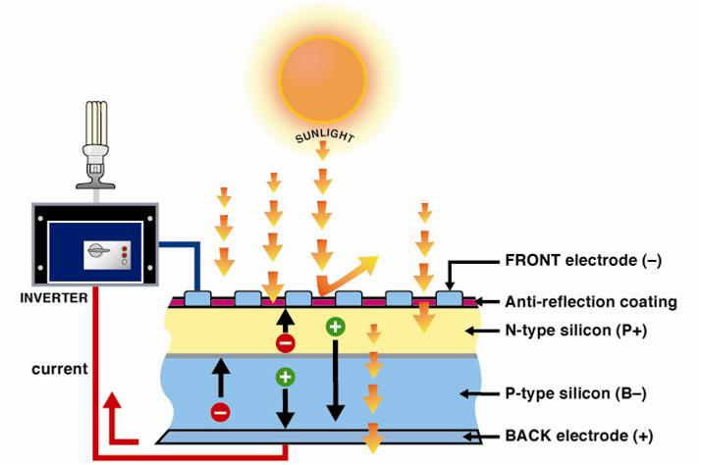

Figure II. Solar Energy Process Diagram Representation

**2) Piezoelectric Based Energy Harvesting Technology**

It was based energy harvesting technology applied to generate electricity from mechanical stressU to harvest vibration energy from humans walking, machinery vibrating, or cars moving on roadway is an area of great interest which is generated when a mechanical force applied on a body deformed it generates electric current that can be harnessed by the means of capacitors and electrical circuitry. Many piezoelectric materials are already in use in transformers and various electrical components. It finds extensive use in motor manufacturing, motion sensors and even land mine devices used as weaponry all over the world. There are numerous other applications of piezoelectric effect. **(**Solar Feeds, 2011**)**

The principle of piezoelectricity lies behind the crystals. As shown in Figure III, electrical voltage is induced when crystalline materials are subjected to external force, pressure, or strain. There are several types of natural crystals, found at the surface or deep within the earth, which can be used today to apply piezoelectricity effect such as clear quartz and amazonite. A variety of artificial crystals are formed by chemical compounds, as well. These include Barium Titanate, Lead Titanate, and Lead Zirconate Titanate, etc.

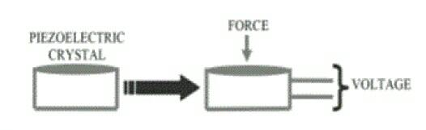

Figure III. Principle of Piezoelectric Effect

The efficiency of piezoelectric devices is influenced by the type of crystals due to the variety of their properties. However, Lead Zirconate Titanate (PZT) crystals are being used widely to achieve a high piezoelectric effect. The ease of fabrication to any complex shape, high material strength and long-life service, resistant to humidity and heat temperature over 100°C, are all distinctive factors of PZT. (Innov Ener Res, Vol 5(1), 2016) [5]

**3) Wind Energy System**

This was created by the unequal heating of the Earth's surface. This wind turbines may convert the kinetic energy in clean electricity. When the wind spins the wind turbine's blades, a rotor captures the kinetic energy of the wind and converts it into rotary motion to drive the generator. It turns energy in the wind into electricity using the aerodynamic force created by the rotor blades when the wind flows across the blade, the air pressure on one side of the blade decreases..

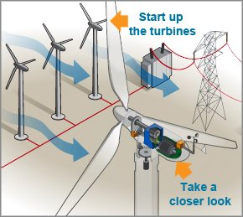

Figure IV. Wind Turbines

*Based on the data gathered by the project developers Solar and Wind Energy System appeared to be complex and strict in using. The initial cost of a solar system is fairly high and also weather dependent. Meanwhile, wind energy system like wind turbines has a similar drawback to solar energy in that it is not constant. Although wind energy is sustainable and will never run out, the wind isn’t always blowing, that is why it is often find on top of hills or out at sea. In these locations, there are fewer land obstacles to reduce the force of the wind. While Piezoelectric Based Energy Harvesting Technology itself is both renewable and sustainable. The vibration energy will never run out, unlike reserves of fossil fuels. This makes it a good choice of energy for a sustainable power supply which can be used by most people. The project developers picked Piezoelectric Based Energy Harvesting Technology as their power generation systems because by using piezoelectric energy to generate electricity, we are helping to reduce our dependency on fossil fuel alternatives. And since movement is everywhere, the ability to capture this energy cheaply would be a significant advancement toward greater efficiency and cleaner energy production. It has huge potential. It’s both renewable and sustainable and is present in a wide variety of places.*

**Piezoelectric Energy Harvesting Elements**

This part will show different piezoelectric energy harvesting elements that the project developers being chosen from. The project developers gives a comparison of the varied commercially on the market piezo harvesters that were explored during this work. There are differing kinds of piezoelectric elements on the market commercially like cantilevers, discs, diaphragms, rings, patches, etc.

Although any piezoelectric material can act as an electromechanical generator, the choice of an energy harvester depends on the usable power which will be obtained and its suitableness to serve the requirements of a specific application. There are some of the harvesters shown in the table, others could not be obtained for testing as they were very expensive, while diaphragms were obtained as samples.

|  |  |  |
| --- | --- | --- |
|  | Elements | Applications |
|  | Patches | Sensors  Actuators |
|  | Cantilever | Sensors  Energy harvesting |
|  | Diaphragm | Acoustics  Sensors  Energy harvesting |

Figure V. Piezoelectric Elements

**1) Patches**

This patch transducers were "Smart Materials" having sensor and actuator characteristics could be used as sensors and actuators The patented laminated structure of piezo ceramic, polymer exterior and electrodes were insulated and, at the same time, mechanically robust. (Piezo Technology)

It was a composite structure including a lead zirconate titanate (PZT) wafer and nickel ribbon leads sandwiched between thermoplastic layers. During fabrication, the structure is held together with Kapton (or equivalent) polyimide tape and placed in an autoclave for processing through a prescribed temperature-and-pressure cycle. (Tech Briefs, 2002)

In recent years, researchers have turned their attention towards lead-free and flexible piezoelectric energy harvesters. Figure VI outlines research on flexible patch piezoelectric harvesters.

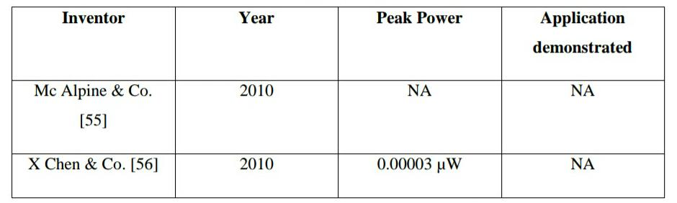

Figure VI. Flexible Patch Piezoelectric Harvesters

**2) Cantilever**

Cantilever geometry is one of the most used structures in piezoelectric energy harvesters, especially for mechanical energy harvesting from vibrations, as large mechanical strain can be produced within the piezoelectric during vibration, and construction of piezoelectric cantilevers is relatively simple. More importantly, the resonance frequency of the fundamental flexural modes of a cantilever is much lower than the other vibration modes of the piezoelectric element. Therefore, a majority of the piezoelectric energy harvesting devices reported today involve a unimorph or bimorph cantilever design. (Applied Physics Reviews, 2014)

Figure VII lists research carried out with piezoelectric cantilever elements.

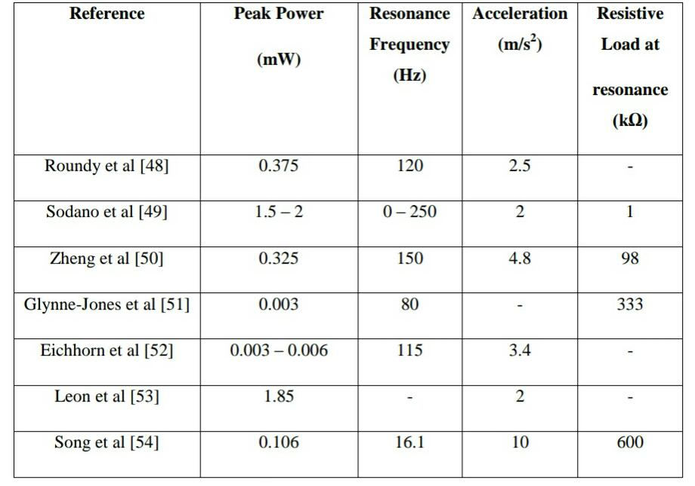

Figure VII. Piezoelectric Cantilever Harvesters

**3) Diaphragm**

Piezoelectric Diaphragms are piezoelectric ceramic disks adhered to a metal plates of brass or nickel-alloy and it is a device that uses the piezoelectric effect, to measure changes in pressure, acceleration, temperature, strain, or force by converting them to an electrical charge.

Circular piezoelectric energy harvesters, in particular piezocomposite diaphragms, have been analyzed by researchers in various setups and excitation profiles. Figure VIII gives a comparison of such harvesters.

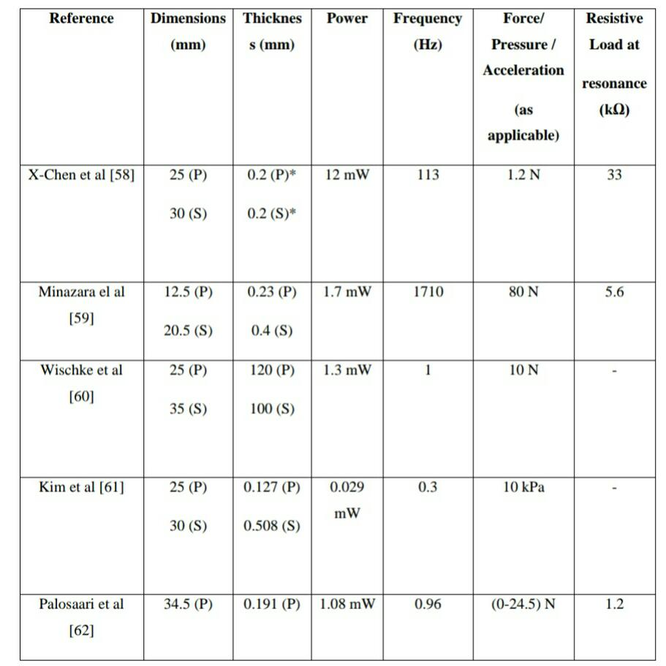

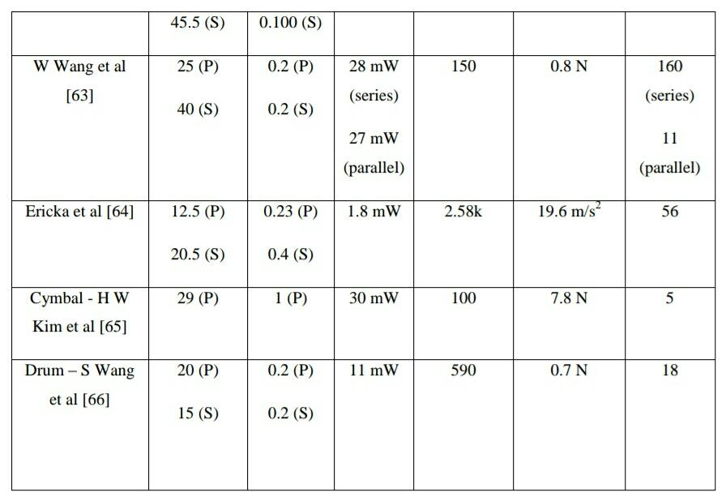

Figure VIII. Piezoelectric Diaphragm Harvesters

*Based on the data gathered by the project developers, Piezoelectric patches and cantilever appeared to be expensive and rare to find in some existing researches since of relatively small external excitations result in output of several volts. The cantilever configuration offers large average strain in the piezoelectric material for a given applied force and low resonant frequencies can be achieved due to the low stiffness of the structure. These energy harvesters are not suitable for low frequency high amplitude applications. It is clear from the above figure that circular piezoelectric diaphragm harvesters generate useful amounts of energy in a wide range of vibration profiles like in wide frequency as well as force range. They can be used in combination to increase the power further. Therefore, the project developers choose Piezoelectric Diaphragm as their piezoelectric energy harvesting elements.*

**Review of Related Studies**

This part will be discussing some studies that are related by the system’s, which will be proposed, focus, both hardware and software utilized. These materials are objective in nature and in high in relevance.

In 2009, the most successful study has been done by Innowattech in Israel in terms of energy harvesting from roads by using piezoelectric materials.

Innowattech developed an efficient storage system to collect and store the electricity produced by these generators.

Rusen Yang, Yong Qin, Liming Dai and Zhong Lin Wang published their study in 2008 developing Power Generation with Laterally Packaged Piezoelectric Fine Wires.

Previously reported nanowire generators were based on vertically aligned piezoelectric nanowires that were attached to a substrate at one end and free to move at the other..

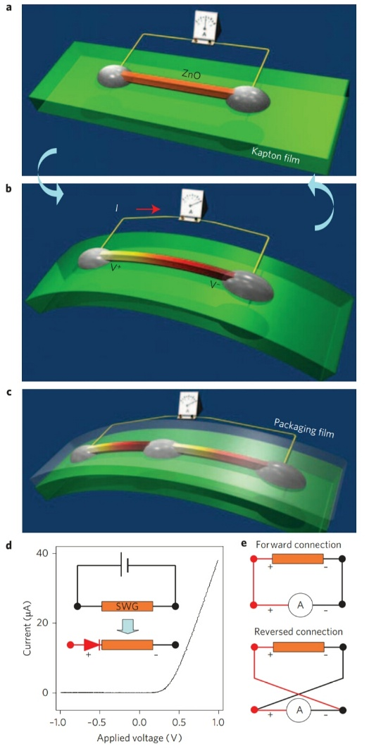

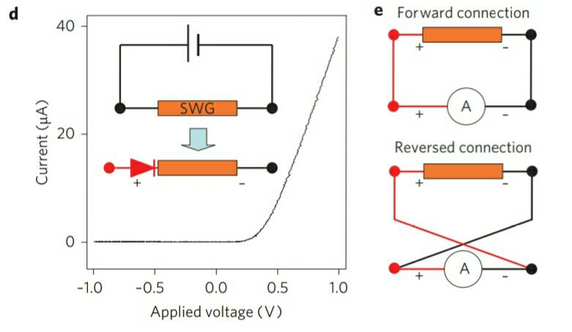

Figure IX. Piezoelectric Fine Wires and Diagram Representation

In summary, they have demonstrated a flexible power generator that has a number of advantages over generators based on vertically aligned nanowire arrays in terms of stability, robustness, cost, manufacturability and its ability to work in fluid and under harsh conditions.

Nazenin takes the train data and first theoretically computes what the expected energy harvesting potential of Mide's piezo energy harvesters will be. She also proposes a novel two degree-of-freedom energy harvesting design to improve performance. (Gure, 2017)

Piezoelectric Energy Harvesting Utilizing Human Locomotion is developed by Guojun Wang in the year of 2010. The purpose of his work is to develop a piezoelectric energy harvesting system that fits within a pair of shoes for unobtrusive, electrical energy generation from the compression and tension energy normally absorbed by the shoes during walking. Specifically, two shoe inserts were developed.

Another important design decision was to keep the Piezo-Element non-intrusive and comfortable for users. For “Contact Phase” Piezo-Element, this means the design will strive to maintain the cushioning property of shoe, while keeping the thickness to a minimum. For “Propulsive Phase” Piezo-Element, this means the design will strive to maintain the flexibility, while keeping the oversize and thickness to a minimum.

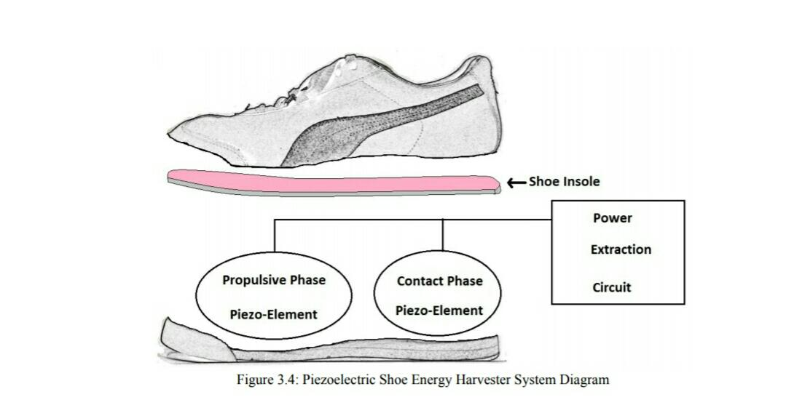

Figure X. Piezoelectric Shoe Energy Harvester System Design

The objective of the study is to continue the work outlined above, dramatically increasing the mechanical to electrical power conversion efficiency of piezoelectric materials when subjected to stress caused by the walking foot. The goal is to increase the current accepted maximum output of PVDF and PZT combined power output from 2.7mW to 5mW per foot or to ~10mW per person. (Wang, 2010)

Team Piezo of University of Maryland in 2017 developed Piezoelectric Sensing and Energy Harvesting in Touchscreens. They investigated the increasing demands on smartphone batteries by developing a touchscreen prototype that integrates piezoelectric materials to sense touch location and generate energy for the battery. The touchscreen prototype uses a piezoelectric element with patterned electrodes that extract a current when touched. A circuit with an Arduino microcontroller successfully senses the location of the activated piezoelectric sections.

Team Piezo’s goal for this project was to develop a prototype piezoelectric touchscreen with the ability to sense touch location, generate energy, and recharge a battery. Through FEA computer simulations, the team modeled the piezoelectric response to different loading conditions. This visualization of the stress and strain produced by various applied forces directed the team to mount the prototype on a laser cut grid matching the pattern of the etched electrodes.

The prototype successfully showed that location sensing could be accomplished by etching a grid pattern into the electrodes on both sides of a piezoelectric tile. This process creates electrically separated segments that experience varying voltage drops based on the location of the force applied to the piezoelectric tile. Forcing energy into a battery requires the voltage of the source to be higher than the voltage of the battery, which are typically at least nine volts. The voltage from the piezoelectric tile measured across a 10kΩ resistor was typically under 10mV from the prototype grid. The non-resonant waveform produced by tapping the piezoelectric element did not work with transformers, and charging a capacitor was unsuccessful because the negative voltages in the waveform caused immediate discharge. (Bremerman, Bronocco, Caffey, Kent, Reed, Lee, Mukhopadhyay, Patel, Reed, Rother, Stambouli, Verni, Wang, 2017)

Application of Piezoelectric Transducer in Energy Harvesting in Pavement by Xiaochen Xu, Dongwei Cao, Hailu Yang, and Ming He in 2017. Their study lead to Piezoelectric box be installed in urban roads and highways should have different requirements. Designing several different laying ways and paving ways is feasible, urban road has lower requirements on road driving than highway, laying piezoelectric boxes may affect road performance, such as long-term run formed uniform settlement and during the use of roads, second pressure may dense the road again and piezoelectric boxes location high out road; the design speed of urban road is lower, the vibration frequency of piezoelectric producer should be lower, traffic composition is complex, it is difficult to always keep the piezoelectric boxes work at the perfect frequency. Highway through remote suburb,, power system is not perfect and maintenance is difficult, through piezoelectric device of road can power itself and solve the problem; laying on highway should focused on the durability of piezoelectric devices, guarantee no larger uniform settlement in long-term run situation; Highway running speed is higher, the self vibration frequency of piezoelectric should be higher, determined by road actual running speed, about 80% of design speed. Not only limited to laying under road, attachments can be embedded in the tracks, collecting vibrational energy when rail traffic going through.

To conclude, The average power produced by the Heel Strike System is much less than the target of 0.5 W. This might be attributable to several issues that were found in the development of the Heel Strike. It was found in the later stage of development that the mechanical forces resulting from the oscillation of the bimorph crystal stacks were not completely canceled, and as a result an opposing toque from the unbalanced bimorph forces was applied to the cam. This leads to a force opposing the input to the Heel Strike Generator so as the user steps down, there is some resistance and not all of the downward force would be used to oscillate the bimorph stacks. This results in lower mechanical to electric efficiency. The variations in the stiffness of the bimorph stack assemblies can cause the mechanical load to be unbalanced because the variations occur in stacks that are phased to cancel each other. These issues should be addressed to determine if the power output can be increased to the target level of 0.5 W. If the power output can be increased to the target level by addressing some or all of these issues, further Testing of the Heel Strike System at the extreme hot and cold temperatures is recommended. (Article  in  Energy Conversion and Management, 2009)

Pavegen Systems technology company of London unveils the future of digital flooring introduced a Pavegen Tile which is a piezoelectric tile that harvests the kinetic energy created by a footstep. These tiles are being laid underneath pavements in high traffic areas such as airports, schools, and train stations.

Jiangming Kan, Robert J. Ross, Xiping Wang, and Wenbin Li of Beijing Forestry University in 2017 studied Energy Harvesting from Wood Floor Vibration Using a Piezoelectric Generator. They investigate various methods and technologies surrounding energy usage in wood structures. A significant amount of research has been conducted to investigate energy harvesting for a wide range of applications. (Kan, J.;Ross, R.J.; Wang, X.; Li, Wenbin. 2017)

In 2008, Club Watt in Rotterdam, Netherlands, are beginning to power their nightclub by the use of piezoelectric crystals underneath the dance floor. The kinetic energy produced by a bulk of party-goers dancing, generates an enormous amount of electrical energy which the Club utilizes to power the variable lights and amplified music that make them go. (Elisabeth Rosenthal, 2008)

In 2010, McAlpine et al. described a method to manufacture flexible nanogenerators. The team fabricated PZT nanofibers and transferred them onto a silicone substrate to get a highly flexible nanogenerator (figure XI). Applications may include implants inside the human body (using lead free materials) to power life support devices like pacemakers. (McAlphine, 2010) [24]

+

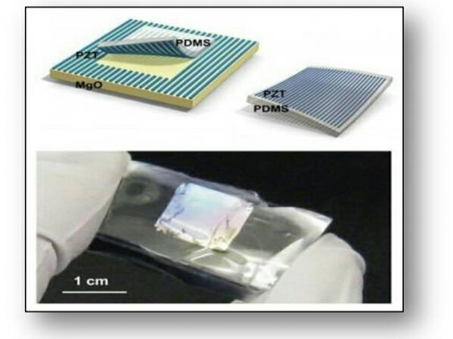

Figure XI. Silicone embedded PZT

A group of engineers from Arizona State University, Michigan Technological University, and the company NanoSonic have created a backpack that, through the use of piezoelectricity, actually generates power.

These traps which were made from polyvinylidene fluoride (PVDF) - a strong, flexible material that felt similar to nylon generates an electrical charge from applied stress. The developers estimate that when shouldered with a 100 pound load -- a typical pack weight for soldiers, for whom the pack was first devised -- and walking at 2-3 mph, the straps could generate 45.6 milliwatts (mW) of power.

According to Henry Sodano, one of the device's developers, from Arizona State University, "In general, we want to accumulate the power before using it so that we could walk for 20 minutes then talk for 2.5 minutes. (Collin Dunn, 200

This energy wastes because of deflections o tires in a passenger car. With the concept of arrays of piezos, 14 stacks of piezoelectric devices of the same size can be placed inside the tire. These wireless devices are generally hard to reach and their life span are mainly limited to the capacity of their powering systems. (ASME, 2008

Veranu is an innovative technology implemented in the raised floor with high added value that converts, by piezoelectric effect, the kinetic energy of the steps into clean electrical energy. Veranu solution is used to supply LED lights and detect pedestrians positions and movements, information very useful for security, consumer tracking and data collection applications. The technology is made with recycled materials to reduce CO2 emissions, production costs and meet the needs of end customers, mainly public and private companies with transit areas or aggregation areas like squares, airports, train stations. (Veranu, 2017)

Soundpower Corp., a company created the Power Generating Floor in Train Stations Light Up Holiday Displays is a new innovation that a piezoelectric power mat installed outside a popular Japanese train station is introducing commuters to the usefulness of self-generating energy.

According to planner Yoshiaki Takuya from Soundpower Corp., a person that weighs about 135 lbs generates 0.1 watts in the one second they usually take to step on the tile. (Jose Fermoso, 2008)

*C. Conclusion*

Being independent from man and animal power sources since the start of the economic age at greater energy levels, was the greatest innovation because the time passes by, the additional technological enhancements occur at the side of wireless networks. The additional device measure in our lives therefore, elevating the standard of life, production and work.

To conclude, the study of literature has reviewed the comparisons on what type of energy harvester and elements are used. It also narrates the different methods of harvesting footsteps, the power output and in some cases the applications. By comparing the harvesting energy technologies located on the body and other materials it is revealed that for body located harvester the power output depends on the physiological parameters. The studies recommends more exploration on the piezoelectric properties to optimize the power output in order to use the technology for different application.

Previous studies have shown that not only are piezoelectric materials feasible for energy harvesting but they are feasible also as an energy harnessing medium in shoes during walking. It also focuses on the energy harvesting aspect of the existing Piezoelectric based system and points out its flaws. It shows how the concept of harvesting of energy and has changed in modern times. The paper points out the shortcomings of Piezoelectric energy harvesting systems in identifying and preventing sophisticated energy loss and over consumption of energy in a environment.

In all, most of the research on the piezoelectric harvesting technology in engineering is still in the exploratory stage. Although the previous studies have conducted preliminary theoretical analysis and laboratory tests, lack of engineering practice still limits the promotion of this new innovative green technology. But, this technology will be available and successful as far and wide with a little bit of research and test.

Chapter III

**Methodology**

The research methodology and procedures used in the current study are systematically presented and discussed in this chapter. This includes details on different processes that would be used in order to develop the design project. Likewise in this section, different developmental phases of the study are shown. Furthermore, thorough discussion of the project’s design and development procedures are included in this chapter. This also contains explanations of the several evaluation and consistency tests that the project would undergo to ensure design stability and reliability.

*A. General Method Used*

This study used developmental method of research. This describes how the system will work briefly and the design methodology used to achieve the project. The project was design to provide wireless charging station using new technologies that uses microcontroller and android application for device control. The highlights of the system as shown in figure XII are the connections between different types of components that the proponents will use to build the project. The method will base to the existing charging stations that available from different convenience store in the Philippines. The proponents will upgrade the method by the use of piezoelectric technology wherein it will use as an power source, wireless charging pad to enable the wireless charging system, solar panel to harvest the energy comes from the sun and use as a power source, and camera for the monitoring security system.

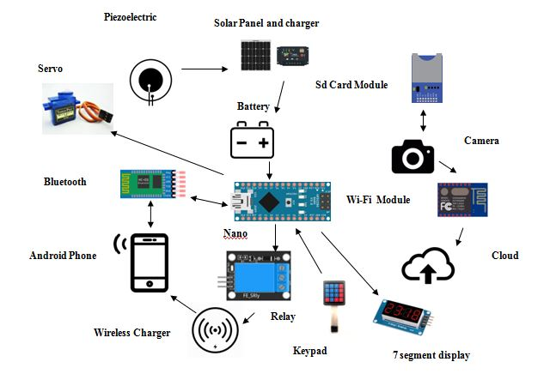

Figure XII. System Model Overview

Figure 1 System Design Diagram

*B. Procedure*

Background research completed it became clear what basic design components the entire system would require:

**Requirements Specification**

Design of Mobile phone Charging Station using Piezoelectric Technology is form from different features rather than wireless charging. The proponents use the opportunity to build up new types of a charging station and it will feature the following below:

* **Charging Battery using Piezoelectric Technology**

The system battery will be charge by the piezo technology by stepping on it.

* **Wireless Charging**

The system will be wirelessly charging. It will not use any traditional wires or cords to charge the mobile phone.

* **Automatic Charging Cut-Off**

When the 30 minutes given time is up the system will automatically cut off the charging process and it will be indicated to the android app.

* **Monitoring System**

The station has a camera to use as a monitoring system. This camera will record the situation around the station place and it will help the owner or staff if some unnecessary things happens.

* **Solar Power Source**

The system will be help powered by solar energy. It is a back-up power source if the system or piezoelectric is not in used.

* **Security System**

The system uses security system with the integration of keypad security protocol.

This describes and establishes the basis of how the system works and interacts to the user.

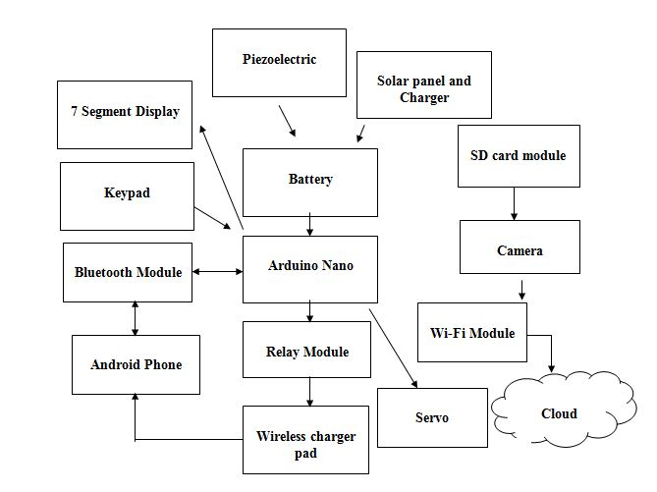

Figure XIII. System Model

TABLE I

Requirements Specification of the Vision System

|  |  |  |
| --- | --- | --- |
| **Marketing Requirement** | **Engineering Requirement** | **Justification** |
| 1 | Utilization of using Arduino Uno for processing. | The utilization of this device is used to be the microprocessor requires the system to work. All of the process will be on the Arduino |
| 10 | Utilization of using Wi-Fi unit to transmit data to the owner. | The data collected must be sent to the cloud storage. For security purpose. |
| 6 | The complete system can charge mobile phone up to 6 devices. | It will charge mobile phone up to 6 devices at the same time. |
| 3,5 | Regulated power within device specifications will be supplied from or charge by the piezo disk and solar panel. | To charge the battery for the system to continue to work. This the main power source for the system and a solar panel system consist of panel and charger for back-up power source. |
| 2 | The system used Bluetooth for wireless connection between android and the system. | The system will require Bluetooth connection for the system to notify user. |
| 1, 2, 3, 4, 5, 6, 7, 8, 9, 10 | Utilize a Piezoelectric Charging station. | The final design will charge mobile phone powered by piezo disk. |
| **Marketing Requirements** | | |
| 1 | The system allows the use of Arduino Uno as a main board | |
| 2 | Device connects to Bluetooth module to communicate with android app. | |
| 3 | Piezo Disk used as a power source of the system | |
| 4 | Charge the mobile phone at maximum of 30 minutes. | |
| 5 | Solar panel for back-up power source. | |
| 6 | Up to 6 devices can charge at the same time. | |
| 7 | Security Monitoring Camera. | |
| 8 | Cloud Storage for video feed. | |
| 9 | Android Application for notification. | |
| 10 | Wi-Fi for cloud connection. | |

Table I shows the requirements specification of Home Security and Monitoring System. It also shows the Marketing Requirements of the proposed system. Marketing requirements tackles about how the process and what is the use to engineering requirements.

**Design**

It defines or refines and describes all important aspects of the prototype focusing on the selection of materials; development or system design of the prototype, flowchart, block diagram, software and hardware.

**System Design**

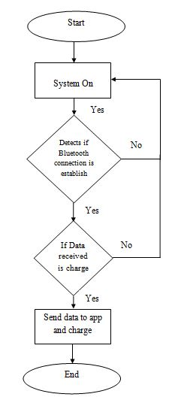

Figure XIV. Flowchart of the System

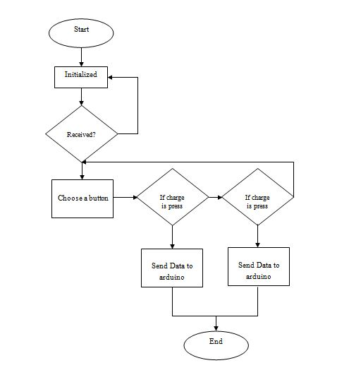 The flowchart shows the process of the system for activity connection. The system is on and if the system detects or connects to android it will send data to owner’s mobile phone for notification and charges the phone.

Figure XV. Flowchart of the Mobile Application

The flowchart of the system shows the process of the system for mobile application. When the program runs it automatically check if the system received an incoming serial connection for the system to check if it is available for charging. If the system initialized and gets a serial connection, it is ready for charging.

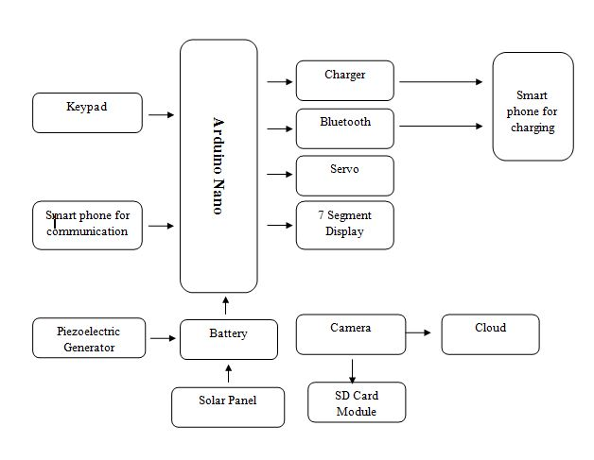

Figure XVI. Level 0 Block Diagram of Power Generation by Stepping using Piezoelectric

Figure XVI illustrates the level 0 diagram of The Smart Phone Charging Station using Piezoelectric Technology. It shows the input of level 0 diagram of piezoelectric generator that will be used to power Arduino to be used to communicate and charge the android phone. Arduino will be the main processor. It takes control with communication between android. It has a power source from piezoelectric generator. When piezo is not in use, the back-up power will go and get energy from the sun. The camera gets feed and send it over the internet or the cloud.

TABLE II  
LEVEL 0 FUNCTIONAL REQUIREMENTS OF THE MOBILE PHONE CHARGING STATION USING PIEZOELECTRIC TECHNOLOGY

Mobile phone Charging Station using Piezoelectric Technology

Input

* User Control: Charging
* Arduino, Piezoelectric, Wireless Pad

Output

* Power, Send data via Bluetooth

Fuctionality

* Wirelessly charging phone through the lapse of 30 minutes

Table II shows the level 0 functional requirements of the Mobile phone charging using piezoelectricity generator. The title of the module is Cellphone Charging Station using Piezoelectric Technology. Its inputs are from Piezoelectric to Arduino, Wireless Pad to User Smartphone. The outputs are Power charge, captured video send to the cloud and charge the mobile phone. The functionality of this module includes notifies the user’s smart phone if it charge and the time limit is acquired.

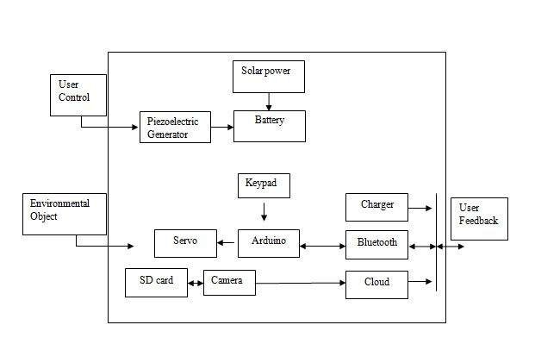

Figure XVII. Level 1 Diagram of the Vision System

Figure XVII illustrates the level 1 diagram of the Vision System. Level 1 diagram provides system architecture with all modules and its interconnections. The Arduino is the main memory module that processes the system. It will process the serial communication between the system and the android. After the processes have done, it will do the next process allocated or commanded. It will charge the user’s phone and will notify if it is done. It has security camera for the system can monitor of what’s happening and send it to the cloud storage.

TABLE III  
Level 1 Functional Requirements of Bluetooth Module

Module

Bluetooth Module

Output

Process data coming from the system to android and vice versa.

Fuctionality

Allows sharing data between Arduino and Smartphone wirelessly.

Input

Power input: +3.3VDC (Bluetooth module)

Table III shows the level 1 functional requirements of the Bluetooth Module. The first row refers to the title of the module. The second row refers to the inputs of the system. The third row refers to the output. The last row refers to the functionality. The title of the module is Bluetooth Module. The input is designated as an input pin can be read as high (3V3) or low (0V). The outputs are A GPIO pin designated as an output pin can be set to high (3V3) or low (0V).

TABLE IV  
LEVEL 1 FUNCTIONAL REQUIREMENTS OF THE ARDUINO UNO

Module

ARDUINO UNO

Input

* 5V DC for power
* Receive inputs and outputs from the system.

Output

* Process the data from all inputs in the system.

Fuctionality

* Able to process the different data coming from different module so that the components will perform their specific tasks.

Table IV shows the level 1 functional requirements of Arduino Uno. The title of the module is Arduino Uno. Its input is from the 5v dc power to be able to use to power the Arduino Uno and receive inputs and outputs from the system. The output of the Arduino is to process the data from all the inputs in the system. Arduino Uno will able to process the different data coming from the different module so that the components will perform their specific tasks.

TABLE V

|  |  |
| --- | --- |
| Module | MATRIX KEYPAD |
| Input | -Inputs data coming from the user to the Arduino |
| Output | -Gets the input from the user to output to Arduino. |
| Functionality | -Able to input data to Arduino thru pressing keypad. |

LVL 1 FUNCTIONAL REQUIREMENTS OF THE MATRIX KEYPAD

Table V shows the level 1 functional requirements of the Matrix Keypad. The title of the module is Matrix Keypad. Its input was data coming from the user to the Arduino. The output of the keypad is from the user who input data and output the data to Arduino. The functionality of the keypad is able to input data to the Arduino by pressing the keypad.

TABLE VI

LEVEL 1 FUNCTIONAL REQUIRMENTS OF SG90 SERVO

|  |  |
| --- | --- |
| Module | SG90 SERVO |
| Input | - Input the degree angle of the position of the servo. |
| Output | - Sets the position of the angle of the servo. |
| Functionality | -Able to open or closed the mini door of the system. |

Table VI shows the level 1 functional requirements of the SG90 Servo. The title of the module is SG90 servo. It inputs the degree position of the servo. The output of the Servo is to set the angle rotation in degree. The functionality of the SG90 it to be able to open the system door of the system.

TABLE VII

LEVEL 1 FUNCTIONAL REQUIRMENTS OF LCD SCREEN

|  |  |
| --- | --- |
| Module | LCD SCREEN |
| Input | - None |
| Output | - Display characters or data from Arduino. |
| Functionality | -Able to display series of data to be able to see by the user. |

Table VII shows the level 1 functional requirements of the LCD SCREEN. The title of the module is LCD SCREEN. There are no inputs from the LCD screen. The output of the LCD is to set and display characters of data from the Arduino. The functionality of the LCD SCREEN is to be able to display series of data to be able to see by the user.

TABLE VIII

LEVEL 1 FUNCTIONAL REQUIREMENTS OF PIEZOELECTRIC DISK

|  |  |
| --- | --- |
| Module | PIEZOELECTRIC DISK |
| Input | - Kinetic energy. |
| Output | - Produced electricity to store to battery thru kinetic energy. |
| Functionality | -Stores energy to the battery and power the charging cycle. |

Table VIII shows the level 1 functional requirements of the Piezoelectric disk. The title of the module is Piezoelectric disk. The input to the piezo was thru kinetic energy. The output of the piezo is to produces electricity. The functionality of the Piezoelectric disk is to produces electricity to be stored in the battery.

TABLE IX

LEVEL 1 FUNCTIONAL REQUIRMENTS OF SOLAR PANEL SYSTEM

|  |  |
| --- | --- |
| Module | Solar Panel System |
| Input | - Gets the input from the sun and converts energy to electricity. |
| Output | - Converted energy will be stored to the battery. |
| Functionality | -Stores energy to the battery and power the charging cycle. |

Table IX shows the level 1 functional requirements of the Solar Panel System. The title of the module is Solar Panel System. The input is coming from the sun. The Output is converted the energy from solar to electricity to store electricity. The functionality is to store energy to the battery and power the charging cycle.

TABLE X

LEVEL 1 FUNCTIONAL REQUIRMENTS OF BRIDGE RECTIFIER DIODES

|  |  |
| --- | --- |
| Module | Bridge Rectifier Diodes |
| Input | - Converts AC Current from piezo to DC. |
| Output | - Convert dc voltage and to supply the Arduino. |
| Functionality | - Conversion of AC to DC converter to be used to supply to the Arduino. |

Table X shows the level 1 functional requirements of the Bridge Rectifier Diodes. The title of the module is Bridge Rectifier Diodes. It inputs AC current from piezo. The output of the diode is the converted DC current and stores the dc current in the battery. The functionality is the conversion of AC to DC to be store in the battery.

TABLE XI

LEVEL 1 FUNCTIONAL REQUIRMENTS OF WIRELESS CHARGING

|  |  |
| --- | --- |
| Module | Wireless Charger |
| Input | - 5V DC |
| Output | -Output 5V DC TO Receiver. |
| Functionality | - Able to wirelessly charge the mobile phone. |

Table XI shows the level 1 functional requirements of the Wireless Charging. The title of the module is Wireless Charger. It inputs 5V dc to supply the transmitter. The output is 5V DC to transmit to mobile phone wireless transmitter. The functionality is to be able to wirelessly charge the mobile phone.

TABLE XII

LVL 1 FUNCTIONAL REQUIRMENTS OF WIRELESS IP CAMERA

|  |  |
| --- | --- |
| Module | Wireless Ip Camera |
| Input | - 5V DC |
| Output | -Output images and video taken from recording. |
| Functionality | - To provides security for the system. |

Table XII shows the lvl 1 functional requirements of the Wireless Ip Camera. The title of the module is Wireless Ip Camera. It inputs 5V dc to supply power to the camera. The output of the camera is to send and save images and video taken from recording. The functionality is to provide security for the system.

Figure XVIII. Physical View of the Vision System

Figure XVIII illustrates the physical view of the Vision System. It shows how will be the sensors located for the system to process. It illustrates the camera where it was placed and how the position for the camera angle for greater camera vision. It also illustrate how the PIR will be used and the angle for better motion detection. Over all, figure 10 will demonstrate and illustrate the physical view and vision system.

**Software Coding and Hardware Construction**

There are coding language that will be used in the software and hardware prototyping, these are:

a. Arduino IDE Language consist of Java c/c++

b. MIT App Inventor 2

A. Arduino Software (IDE) makes it easy to write code and upload it to the board. It runs on Windows, Mac OS X, and Linux. This software can be used with any Arduino board. It is a cross-platform application written in the programming language Java and c/c++. It is used to write and upload programs to Arduino board.

B. MIT App Inventor 2 is an open-source web application originally provided by Google, and now maintained by the Massachusetts Institute of Technology (MIT). MIT app inventor 2 will be used for the development of android app for the user to be used.

*C. Verification and Testing*

Verification and testing discuss and evaluates the development phase of the prototype and to determine on how you will test each of the parts of the prototype.

**Unit Testing**

Unit test establishes that a system module performs a single unit of functionality to a prescribed specification. It is a test of functionality of a system module in isolation.

==

TABLE XIII

table for Unit Testing

|  |  |  |  |  |
| --- | --- | --- | --- | --- |
| **Test ID** | **Description** | **Expected Result** | **Actual Result** | **Date of Testing** |
| BM-UT-01 | Bluetooth communication to communicate between Arduino and android. | The overall test is that the program can communicate between the two devices. |  | January 20, 2019 |
| PD-UT-01 | To produce electricity with the help of piezo electric disk. | The overall test results that piezoelectric disk can produce electricity to store in the battery. |  | January 20, 2019 |
| SPS-UT-01 | Produced electricity using solar panel system. | The overall test result that you can produce enough electricity using 12 volts and 10 watts with a maximum peak voltage in the afternoon. |  | January 20, 2019 |
| TMD-UT-01 | Display series of numbers for countdown timer. | The overall test results that it was successfully display numbers for countdown. |  | January 15, 2019 |
| MK-UT-01 | It is used to unlock the door lock. | The overall test result shows that it can be use for unlocking the door. |  | January 16, 2019 |
| SG90-UT-01 | To be used to open the door mechanism. | SG90 is now interfaced with proper coding with other module with Arduino. |  | January 16, 2019 |
| WC-UT-01 | To charger wirelessly without the use of wiring. | The overall expected test result is to successfully set up a wireless charger. |  | January 15, 2019 |
| LS-UT-01 | To display characters data in the screen. | The overall expected result shows that 16x2 LCD screen is enough to display sets of characters. |  | January 10, 2019 |
| AU-UT-01 | The microcontroller of the system. | The expected test result shows that the Arduino Uno has enough pins to be used by the system. |  | December 29, 2018 |
| BRD-UT-01 | Converts AC current from piezoelectric | The overall expected result shows that the successfully Converts AC To DC. |  | December 29, 2018 |
| WIC-UT-01 | To Record images and video for security purposes. | The overall expected result shows that it can take image and video and send to the database. |  | December 30, 2018 |
| RM-UT-01 | Use to manipulate and control the wireless function. | The overall expected result shows that it can control the wireless charger. |  |  |

Table XIII shows the table of the parts that will be test for the next chapter. It shows the table id in the column I that is arrange according to their level of difficulties. Second, the description is to show the name of all the parts that will be used in the testing period. Column 3 for expected results, here will be tackled the expected results from the testing period and column 4 for actual results and column 5 for date of testing.

TABLE XIV

UNIT TEST OF BLUETOOTH MODULE

|  |  |  |  |  |  |  |  |
| --- | --- | --- | --- | --- | --- | --- | --- |
| Test Writer: | | Lalaine A. Dinglasan | | | | | |
| Test Case Name: | | Bluetooth Module unit test#1 | | | | Test Id: | BM-UT-01 |
| Description: | | Bluetooth communication to communicate between Arduino and android. | | | | Type: | black Box  white box |
| Tester information | | | | | | | |
| Name of Tester: | | Michael Jerson T. Molines | | | | Date: | February 20, 2019 |
| Hardware Version: | | Bluetooth version 1 | | | | Time: | 1:00 pm |
| Setup: | | Using Arduino IDE of program to code and connect Bluetooth to the Arduino to communicate with android phone | | | | | |
| Step | Action | Expected Result | Pass | Fail | N/A | Comments | |
| 1 | Write a program to communicate to android app | IDE should generate no warning and error. |  |  |  |  | |
| 2 | Configure the module and see if it connects. | The module should connect with the android successfully. |  |  |  |  | |
| 3 | Test and send data to android for the last testing. | Sending of data to know if it is working. |  |  |  |  | |
| Overall test result: | | |  |  |  |  | |

Table XIV shows the result of unit test of Bluetooth Module. In Step 1, The Bluetooth module to communicate with the mobile app. In Step 2, to configure the module and see if it connects. In Step 3, test and send data to android for the last testing.

TABLE XV

UNIT TEST OF PIEZOELECTRIC GENERATOR

|  |  |  |  |  |  |  |  |  |
| --- | --- | --- | --- | --- | --- | --- | --- | --- |
| Test Writer: | | Lalaine A. Dinglasan | | | | | | |
| Test Case Name: | | Piezoelectric Generator Unit Testing #1 | | | | Test Id: | | PG-UT-01 |
| Description: | | To produce electricity with the help of piezo electric disk. | | | | Type: | | black Box  white box |
| Tester information | | | | | | | | |
| Name of Tester: | | Michael Jerson T. Molines | | | | Date: | | February 22, 2019 |
| Hardware Version: | | Piezoelectric Generator version 1 | | | | Time: | | 4:00 pm |
| Setup: | | Using piezoelectric element to generate electricity. | | | | | | |
| Step | Action | Expected Result | Pass | Fail | N/A | | Comments | |
| 1 | Design a piezo tile that can be used to produce efficient electricity. | The result should show that piezo can produced enough voltage and current in parallel and series connection. |  |  |  | |  | |
| 2 | Connect the piezo in parallel. | The result should show that connecting piezo in parallel can produced or in increase amount of current. |  |  |  | |  | |
| 3 | Connect the piezo in series. | The result should show that when piezo is connected in series, it increases the voltage and the current is the same. |  |  |  | |  | |
| 4 | Connect the piezo in series-parallel combination. | The result should show that series-parallel combination produces or increases voltage and current. |  |  |  | |  | |
| Overall test result: | | |  |  |  | |  | |

Table XV shows the result of unit test of Piezoelectric Generator. In Step 1, is to design a piezo tile that can be used to produce efficient electricity. In Step 2, connect the piezo in parallel. In Step 3, connect the piezo in series. In Step 4, connect the piezo in series-parallel combination.

TABLE XVI

UNIT TEST OF SOLAR PANEL SYSTEM

|  |  |  |  |  |  |  |  |
| --- | --- | --- | --- | --- | --- | --- | --- |
| Test Writer: | | Michael Jerson T. Molines | | | | | |
| Test Case Name: | | Solar Panel System Unit Testing #1 | | | | Test Id: | SPS-UT-01 |
| Description: | | Produced electricity using solar panel system. | | | | Type: | black Box  white box |
| Tester information | | | | | | | |
| Name of Tester: | | Michael Jerson T. Molines | | | | Date: | March 1, 2019 |
| Hardware Version: | | Solar Panel System version 1 | | | | Time: | 3:00 pm |
| Setup: | | Setup a panel system to charge and store to the battery. | | | | | |
| Step | Action | Expected Result | Pass | Fail | N/A | Comments | |
| 1 | Test and select proper solar panel system. | The result should show that 12 volts 10 watts and above voltage and wattage can charge 12 volts lead battery. |  |  |  |  | |
| 2 | Test the solar panel in which time of the day is the best time for charging. | Between 11-3 in the afternoon is the peak time and best time to charge the battery. |  |  |  |  | |
| 3 | Getting the temperature of solar panel and test if it affects the charging of the battery. | It affects the efficiency of charging the solar panel. |  |  |  |  | |
| Overall test result: | | |  |  |  |  | |

Table XVI shows the result of unit test of solar panel system. In Step 1, test and select proper solar panel system. In Step 2, test the solar panel in which time of the day is the best time for charging. In Step 3, get the temperature of solar panel and test if it affects the charging of the battery.

TABLE XVII

UNIT TEST OF TM1637 DISPLAY

|  |  |  |  |  |  |  |  |
| --- | --- | --- | --- | --- | --- | --- | --- |
| Test Writer: | | Michael Jerson T. Molines | | | | | |
| Test Case Name: | | TM1637 Display Unit Testing #1 | | | | Test Id: | TMD-UT-01 |
| Description: | | Display series of numbers for countdown timer. | | | | Type: | black Box  white box |
| Tester information | | | | | | | |
| Name of Tester: | | Michael Jerson T. Molines | | | | Date: | March 1, 2019 |
| Hardware Version: | | TM1637 Display version 1 | | | | Time: | 3:00 pm |
| Setup: | | Display data on the segments using Arduino and Arduino IDE. | | | | | |
| Step | Action | Expected Result | Pass |  | N/A | Comments | |
| 1 | Program 30 minutes countdown timer system. | To program a 30 minutes timer system for countdown. |  | Fail |  |  | |
| 2 | Program test examples codes to verify its usage. | IDE should not generate warning or error. |  |  |  |  | |
| 3 | Test the final segment display if it is working properly. | To display proper number according to code. |  |  |  |  | |
| Overall test result: | | |  |  |  |  | |

Table XVII shows the result of unit test of TM1637 Display. In Step 1, program 30 minutes countdown timer system. In Step 2, to program test examples codes to verify its usage. In Step 3, test the final segment display if it is working properly.

TABLE XVIII

UNIT TEST OF MATRIX KEYPAD

|  |  |  |  |  |  |  |  |
| --- | --- | --- | --- | --- | --- | --- | --- |
| Test Writer: | | Michael Jerson T. Molines | | | | | |
| Test Case Name: | | Matrix Keypad Unit Testing #1 | | | | Test Id: | MK-UT-01 |
| Description: | | Used to unlock the door lock system. | | | | Type: | black Box  white box |
| Tester information | | | | | | | |
| Name of Tester: | | Michael Jerson T. Molines | | | | Date: | March 1, 2019 |
| Hardware Version: | | Matrix keypad version 1 | | | | Time: | 3:00 pm |
| Setup: | | The keypad is connected in Arduino pmw 2,3,4,5,6,7,8,9,10 pins. It will be used as a input onto Arduino Uno. | | | | | |
| Step | Action | Expected Result | Pass | Fail | N/A | Comments | |
| 1 | Connect to Arduino and test sample codes. | IDE should not generate warning or error. |  |  |  |  | |
| 2 | Write a program for keypad input if it is working. | The keypad should return a value in IDE. |  |  |  |  | |
| 3 | Write a program to interface with other module. | To successfully works with other module. |  |  |  |  | |
| Overall test result: | | |  |  |  |  | |

Table XVIII shows the result of Matrix keypad. In step 1, the IDE should not generate warning or error. In step 2, the keypad should return a value in IDE. In step 3, to successfully work with other module.

TABLE XIX

UNIT TEST OF BRIDGE RECTIFIER DIODE

|  |  |  |  |  |  |  |  |
| --- | --- | --- | --- | --- | --- | --- | --- |
| Test Writer: | | Michael Jerson T. Molines | | | | | |
| Test Case Name: | | Bridge Rectifier Diode Unit Testing #1 | | | | Test Id: | BRD-UT-01 |
| Description: | | Converts AC current from piezoelectric | | | | Type: | black Box  white box |
| Tester information | | | | | | | |
| Name of Tester: | | Michael Jerson T. Molines | | | | Date: | March 1, 2019 |
| Hardware Version: | | Bridge Rectifier version 1 | | | | Time: | 3:00 pm |
| Setup: | | Converts AC current to DC through rectification. | | | | | |
| Step | Action | Expected Result | Pass | Fail | N/A | Comments | |
| 1 | Test and experiment various diodes and get proper value. | Using 1n4007 diodes for conversion. |  |  |  |  | |
| 2 | Design a circuit for ADC. | Produce a circuit board. |  |  |  |  | |
| 3 | Feed AC current to circuit to convert DC. | Successfully convert ac to dc. |  |  |  |  | |
| Overall test result: | | |  |  |  |  | |

Table XIX shows the results of the unit test of Bridge Rectifier. In step 1, to use 1n4007 diodes for conversion. In step 2, to produce a circuit board. In step 3, to successfully convert ac to dc.

Table XX

RESULTS OF UNIT TEST OF SG90 SERVO

|  |  |  |  |  |  |  |  |
| --- | --- | --- | --- | --- | --- | --- | --- |
| Test Writer: | | Michael Jerson T. Molines | | | | | |
| Test Case Name: | | SG90 Servo Unit Testing #1 | | | | Test Id: | SS-UT-01 |
| Description: | | To be used to open the door mechanism. | | | | Type: | black Box  white box |
| Tester information | | | | | | | |
| Name of Tester: | | Michael Jerson T. Molines | | | | Date: | March 1, 2019 |
| Hardware Version: | | SG90 Servo version 1 | | | | Time: | 3:00 pm |
| Setup: | | Sets the door open or closed with servo. | | | | | |
| Step | Action | Expected Result | Pass | Fail | N/A | Comments | |
| 1 | Test and set SG90 servo motor 90 degrees with Arduino. | Sets SG90 servo to 90 degrees. |  |  |  |  | |
| 2 | Interface with other module. | Actively interface with other module. |  |  |  |  | |
| 3 | Write a code to Arduino IDE. | IDE should not generate warning or errors. |  |  |  |  | |
| Overall test result: | | |  |  |  |  | |

Table XX shows the results of the unit test of SG90 Servo. In step 1, sets SG90 servo to 90 degrees. In step 2, to actively interface with other module. In step 3, the IDE should not generate warning or errors.

Table XXI

RESULT OF UNIT TEST OF WIRELESS CHARGER

|  |  |  |  |  |  |  |  |
| --- | --- | --- | --- | --- | --- | --- | --- |
| Test Writer: | | Michael Jerson T. Molines | | | | | |
| Test Case Name: | | Wireless Charger Unit Testing #1 | | | | Test Id: | WC-UT-01 |
| Description: | | To charger wirelessly without the use of wiring. | | | | Type: | black Box  white box |
| Tester information | | | | | | | |
| Name of Tester: | | Michael Jerson T. Molines | | | | Date: | March 1, 2019 |
| Hardware Version: | | Wireless charger version 1 | | | | Time: | 3:00 pm |
| Setup: | | Setup a wireless charging station. | | | | | |
| Step | Action | Expected Result | Pass | Fail | N/A | Comments | |
| 1 | Test the wireless charger. | Successfully transmit current wirelessly. |  |  |  |  | |
| 2 | Test the efficiency of wireless transmitted. | Receive the voltage transmitted by the transmitter. |  |  |  |  | |
| 3 | Interface with the relay. | Successfully interface and working with relay. |  |  |  |  | |
| Overall test result: | | |  |  |  |  | |

Table XXI shows the result of the test of Wireless charger. In step 1, it successfully transmitted current wirelessly. In step 2, it is successfully received the voltage transmitted by the transmitter. In step 3, it is successfully interface and working with relay.

Table XXII

RESULT OF UNIT TEST OF 16x2 LCD SCREEN

|  |  |  |  |  |  |  |  |
| --- | --- | --- | --- | --- | --- | --- | --- |
| Test Writer: | | Michael Jerson T. Molines | | | | | |
| Test Case Name: | | LCD Screen Unit Testing #1 | | | | Test Id: | LS-UT-01 |
| Description: | | To display characters data in the screen. | | | | Type: | black Box  white box |
| Tester information | | | | | | | |
| Name of Tester: | | Michael Jerson T. Molines | | | | Date: | March 1, 2019 |
| Hardware Version: | | LCD Screen version 1 | | | | Time: | 3:00 pm |
| Setup: | | Setup a wireless charging station. | | | | | |
| Step | Action | Expected Result | Pass | Fail | N/A | Comments | |
| 1 | Write a program to display characters in the screen. | Display character that is being programmed. |  |  |  |  | |
| 2 | Test and experiment with the code of the usage of the lcd. | Successfully execute and display the main program. |  |  |  |  | |
| 3 | Interface with the other module. | Responsively communicate with the microcontroller. |  |  |  |  | |
| Overall test result: | | |  |  |  |  | |

Table XXII shows the results of the unit test of 16x2 LCD Screen. In step 1, it displays the character that is being programmed. In step 2, it is successfully execute and display the main program. In step 3, it is responsively communicate with the microcontroller.

Table XXIII

RESULT OF UNIT TEST OF ARDUINO UNO

|  |  |  |  |  |  |  |  |
| --- | --- | --- | --- | --- | --- | --- | --- |
| Test Writer: | | Michael Jerson T. Molines | | | | | |
| Test Case Name: | | Arduino Uno Unit Testing #1 | | | | Test Id: | AU-UT-01 |
| Description: | | The microcontroller of the system. | | | | Type: | black Box  white box |
| Tester information | | | | | | | |
| Name of Tester: | | Michael Jerson T. Molines | | | | Date: | March 1, 2019 |
| Hardware Version: | | Arduino Uno version 1 | | | | Time: | 3:00 pm |
| Setup: | | Connects with all the modules. | | | | | |
| Step | Action | Expected Result | Pass | Fail | N/A | Comments | |
| 1 | To successfully interface with the modules. | IDE should not generate warning or error. |  |  |  |  | |
| 2 | Write a program for the modules. | It should successfully connect with the all modules. |  |  |  |  | |
| 3 | To make a smaller size of Arduino. | To use the dip chip of the Arduino Uno. |  |  |  |  | |
| Overall test result: | | |  |  |  |  | |

Table XXIII shows the result of the unit test of Arduino Uno. In Step 1, The IDE should not generate warning or error. In Step 2, it should successfully connect with the all modules. In Step 3, to be use the dip chip of the Arduino Uno.

Table XXIV

RESULT OF UNIT TEST OF RELAY MODULE

|  |  |  |  |  |  |  |  |
| --- | --- | --- | --- | --- | --- | --- | --- |
| Test Writer: | | Michael Jerson T. Molines | | | | | |
| Test Case Name: | | Relay Module Unit Testing #1 | | | | Test Id: | AU-UT-01 |
| Description: | | Control the wireless function with relay function. | | | | Type: | black Box  white box |
| Tester information | | | | | | | |
| Name of Tester: | | Michael Jerson T. Molines | | | | Date: | March 1, 2019 |
| Hardware Version: | | Relay Module version 1 | | | | Time: | 3:00 pm |
| Setup: | | The relay module is connected to the PMW pin 11. And the output is connected to the wireless module. | | | | | |
| Step | Action | Expected Result | Pass | Fail | N/A | Comments | |
| 1 | Program the relay with its function. | IDE should not generate warning or error. |  |  |  |  | |
| 2 | Can be use to divert or short the connection of the wireless function. | The expected result shows that it can short or cut the connection between the supply and the Wireless charger. |  |  |  |  | |
| 3 | Interface with the other module. | The module expected result that it can be interface with other module. |  |  |  |  | |
| Overall test result: | | |  |  |  |  | |

Table XXIV shows the result of the unit test of Relay module. In Step 1, The IDE should not generate warning or error. In Step 2, the expected result shows that it can short or cut the connection between the supply and the Wireless charger. In Step 3, the module expected result that it can be interface with other module.

**Integration Testing**

Integration test verifies the operation of the integrated system behavior. It is conducted after the system modules have passed a unit test.

TABLE XXV

table for Integration Testing

|  |  |  |  |  |
| --- | --- | --- | --- | --- |
| Test ID | Description | Expected Result | Actual Result | Date of Testing |
| KS-IT-01 | Open and closed the door of the charging system using SG90 servo by entering the correct password to the keypad. | The overall expected result is that the user can open the door or closed using SG90 by entering the correct password and if the user wishes to change the password, the user can enter the changing password mode and change the previous password with a new one. |  | January 21, 2019 |
| BKMA-IT-01 | Send data to android app thru Bluetooth to display the input from keypad. | The overall expected result is that the user will see the password input thru keypad. It will display the password in the application and activate the timer countdown. |  | January 21, 2019 |
| BMRWC-IT-01 | Connect the system with the app thru Bluetooth to activate the relay to be able wireless charging function. | The expected result shows that the wireless function can be activated via Bluetooth from mobile app. |  | January 21, 2019 |
| AL-IT-01 | Integrate LCD and Arduino to be used as multimeter. | The expected result shows that the Arduino can be used Arduino as multimeter. |  | January 21, 2019 |
| SPSB-IT-01 | Integrate Solar panel to the battery to charge battery. | The expected result shows that the solar panel current is enough to charge the battery. |  | January 21, 2019 |
| PDWC-IT-01 | Integrate piezoelectric disk with the battery. | The expected result shows that the piezo can charge the mobile phone. |  | January 21, 2019 |
| WICW-IT-01 | Connects the Camera to the Wi-Fi to save images and video taken | The expected result shows that the Camera can wirelessly take videos thru Wi-Fi and save to the cloud. |  | January 21, 2019 |

Table XXV shows the table of the parts that will be integrated for the next chapter. It shows the table id in the column I that is arrange according to their level of difficulties. Second, the description is to show the name of all the parts that will be used in the testing period. Column 3 for expected results, here will be tackled the expected results from the testing period and column 4 for actual results and column 5 for date of integration testing.

Table XXVI

INTEGRATION TEST OF KEYPAD SG90 SERVO

|  |  |  |  |  |  |  |  |
| --- | --- | --- | --- | --- | --- | --- | --- |
| Test Writer: | | Michael Jerson T. Molines | | | | | |
| Test Case Name: | | Keypad SG90 Integration Testing #1 | | | | Test Id: | KS-IT-01 |
| Description: | | Keypad is use to unlock the servo to unlock mini door. | | | | Type: | black Box  white box |
| Tester information | | | | | | | |
| Name of Tester: | | Michael Jerson T. Molines | | | | Date: | March 1, 2019 |
| Hardware Version: | | Keypad SG90 Servo version 1 | | | | Time: | 3:00 pm |
| Setup: | | The keypad pins are connected in PMW pins in Arduino from 2-10. The servo motor is connected to A0 of the Arduino. | | | | | |
| Step | Action | Expected Result | Pass | Fail | N/A | Comments | |
| 1 | Enter the correct password in the keypad. | Opens the door of the system if password is correct. |  |  |  |  | |
| 2 | Enter the invalid password in the keypad. | Door remains close because of invalid password. |  |  |  |  | |
| 3 | Configure the keypad and Sg90 servo with the other module for completion. | Successfully configure the modules with each other. |  |  |  |  | |
| Overall test result: | | |  |  |  |  | |

Table XXVI shows the result of integration test of Keypad and SG90 servo. In Step 1, opens the door if the password entered is correct. In Step 2, the door remains close because of invalid password. In Step 3, to successful configure the modules with each other.

Table XXVII

INTEGRATION TEST OF BLUETOOTH KEYPAD TO MOBILE APP

|  |  |  |  |  |  |  |  |
| --- | --- | --- | --- | --- | --- | --- | --- |
| Test Writer: | | Michael Jerson T. Molines | | | | | |
| Test Case Name: | | Bluetooth keypad to Mobile app Integration Testing #1 | | | | Test Id: | BKM-IT-01 |
| Description: | | Bluetooth is to connect the system with the keypad and display input data to the mobile application. | | | | Type: | black Box  white box |
| Tester information | | | | | | | |
| Name of Tester: | | Michael Jerson T. Molines | | | | Date: | March 1, 2019 |
| Hardware Version: | | Bluetooth Keypad to Mobile app version 1 | | | | Time: | 3:00 pm |
| Setup: | | Bluetooth module is connected in PMW pins 0 and 1 wherein, 0 is the rx pin and 1 is the tx pin. Keypad is connected in PMW pins 2-10. The Bluetooth is connected to the app. | | | | | |
| Step | Action | Expected Result | Pass | Fail | N/A | Comments | |
| 1 | Connects Bluetooth to mobile and test. | The expected result of Bluetooth is to connect successful with the mobile app. |  |  |  |  | |
| 2 | Press the keypad and see if the entered keys are displayed in the mobile app. | The expected result of pressing the keys is to see if the keys that are being pressed are displayed on the mobile screen. |  |  |  |  | |
| 3 | Test the keypad module and Bluetooth module with the other module. | Successfully configure the modules with each other. |  |  |  |  | |
| Overall test result: | | |  |  |  |  | |

Table XXVII shows the result of the integration test of Bluetooth keypad to Mobile app. In Step 1, the expected result of Bluetooth is to connect successful with the mobile app. In Step 2, the expected result of pressing the keys is to see if the keys that are being pressed are displayed on the mobile screen. In Step 3, to successful configure the keypad Bluetooth with other modules.

Table XXVIII

INTEGRATION TEST OF BLUETOOTH MOBILE APP WITH RELAY WIRELESS CHARGING

|  |  |  |  |  |  |  |  |
| --- | --- | --- | --- | --- | --- | --- | --- |
| Test Writer: | | Michael Jerson T. Molines | | | | | |
| Test Case Name: | | Bluetooth to Mobile app with Relay Wireless Charging Integration Testing #1 | | | | Test Id: | BMRWC-IT-01 |
| Description: | | Connects the system to Mobile phone thru Bluetooth and wirelessly charge. | | | | Type: | black Box  white box |
| Tester information | | | | | | | |
| Name of Tester: | | Michael Jerson T. Molines | | | | Date: | March 1, 2019 |
| Hardware Version: | | Bluetooth to Mobile with relay wireless charger version 1 | | | | Time: | 3:00 pm |
| Setup: | | Bluetooth module is connected in PMW pins 0 and 1 wherein, 0 is the rx pin and 1 is the tx pin. Keypad is connected in PMW pins 2-10. The Relay pin is connected to PMW pin 11. | | | | | |
| Step | Action | Expected Result | Pass | Fail | N/A | Comments | |
| 1 | Connects Bluetooth to mobile and test. | The expected result of Bluetooth is to connect successful with the mobile app. |  |  |  |  | |
| 2 | Press the button in the mobile app and activate the relay. | The expected result of pressing the button to activate the relay and enable wireless function. |  |  |  |  | |
| 3 | Test and configure with system. | Successfully configure the modules with each other. |  |  |  |  | |
| Overall test result: | | |  |  |  |  | |

Table XXVIII shows the result of the integration test of Bluetooth Mobile app with Relay Wireless Charging. In Step 1, the expected result of Bluetooth is to connect successful with the mobile app. In Step 2, the expected result of pressing the button to activate the relay and enable wireless function. In Step 3, to successful configure the module with other modules.

Table XXIX

INTEGRATION TEST OF ARDUINO LCD SCREEN

|  |  |  |  |  |  |  |  |
| --- | --- | --- | --- | --- | --- | --- | --- |
| Test Writer: | | Michael Jerson T. Molines | | | | | |
| Test Case Name: | | Arduino to LCD Screen Integration Testing #1 | | | | Test Id: | AL-IT-01 |
| Description: | | Arduino is used as a microcontroller to be used as multimeter and the data display in the screen. | | | | Type: | black Box  white box |
| Tester information | | | | | | | |
| Name of Tester: | | Michael Jerson T. Molines | | | | Date: | March 1, 2019 |
| Hardware Version: | | Arduino LCD Screen version 1 | | | | Time: | 3:00 pm |
| Setup: | | LCD Screen is connected to the PMW pins. | | | | | |
| Step | Action | Expected Result | Pass | Fail | N/A | Comments | |
| 1 | Connects the LCD with the Arduino. | The expected result of LCD is to display the readings of the Arduino. |  |  |  |  | |
| 2 | Test the Arduino and display characters | The expected result of LCD screen is to display the coded character correctly. |  |  |  |  | |
| 3 | Test the LCD screen with other module. | Successfully configure the modules with each other. |  |  |  |  | |
| Overall test result: | | |  |  |  |  | |

Table XXIX shows the result of the integration test of Arduino LCD screen. In Step 1, the expected result of LCD is to display the readings of the Arduino. In Step 2, the expected result of LCD screen is to display the coded character correctly. In Step 3, to successful configure the module with other modules.

Table XXX

INTEGRATION TEST OF SOLAR PANEL SYSTEM TO BATTERY

|  |  |  |  |  |  |  |  |
| --- | --- | --- | --- | --- | --- | --- | --- |
| Test Writer: | | Michael Jerson T. Molines | | | | | |
| Test Case Name: | | Solar Panel System to battery Integration Testing #1 | | | | Test Id: | AL-IT-01 |
| Description: | | Solar Panel is used to gather solar energy and stored | | | | Type: | black Box  white box |
| Tester information | | | | | | | |
| Name of Tester: | | Michael Jerson T. Molines | | | | Date: | March 1, 2019 |
| Hardware Version: | | Solar Panel System to battery version 1 | | | | Time: | 3:00 pm |
| Setup: | | Solar Panel System is connected to the charger and stores to the battery. | | | | | |
| Step | Action | Expected Result | Pass | Fail | N/A | Comments | |
| 1 | Connects the Solar panel to the charger and charge the battery. | The expected result of Solar panel system can charge battery. |  |  |  |  | |
| 2 | Test the LCD screen with other module. | Successfully configure the modules with each other. |  |  |  |  | |
| Overall test result: | | |  |  |  |  | |

Table XXX shows the result of the integration test of Solar Panel System with battery. In Step 1, the expected result of Solar panel system can charge battery. In Step 2, successfully configure the modules with each other.

Table XXXI

INTEGRATION TEST OF PIEZOELECTRIC DISK WITH THE WIRELESS CHARGER

|  |  |  |  |  |  |  |  |
| --- | --- | --- | --- | --- | --- | --- | --- |
| Test Writer: | | Michael Jerson T. Molines | | | | | |
| Test Case Name: | | Piezoelectric disk with the wireless charger Integration Testing #1 | | | | Test Id: | PDWC-IT-01 |
| Description: | | Using piezo to produce electricity to store to the battery and supply to the wireless charger. | | | | Type: | black Box  white box |
| Tester information | | | | | | | |
| Name of Tester: | | Michael Jerson T. Molines | | | | Date: | March 1, 2019 |
| Hardware Version: | | Piezoelectric Disk with Wireless Charger version 1 | | | | Time: | 3:00 pm |
| Setup: | | Piezoelectric Disk is connected to the Battery and the battery supply the Wireless charger. | | | | | |
| Step | Action | Expected Result | Pass | Fail | N/A | Comments | |
| 1 | Connects the Piezo disk to the battery and charge the battery. | The expected result of Piezoelectric disk can charge battery. |  |  |  |  | |
| 2 | Test the Piezoelectric Disk with other module. | Successfully configure the modules with each other. |  |  |  |  | |
| Overall test result: | | |  |  |  |  | |

Table XXXI shows the result of the integration test of Piezoelectric Disk with wireless charger. In Step 1, the expected result of Piezoelectric disk can charge battery. In Step 2, successfully configure the modules with each other.

Table XXXII

INTEGRATION TEST OF WIRELESS IP CAMERA WITH WIFI

|  |  |  |  |  |  |  |  |
| --- | --- | --- | --- | --- | --- | --- | --- |
| Test Writer: | | Michael Jerson T. Molines | | | | | |
| Test Case Name: | | Wireless IP Camera with Wi-Fi Integration Testing #1 | | | | Test Id: | PDWC-IT-01 |
| Description: | | Using a Wireless IP Camera to saves video and save to cloud using Wi-Fi. | | | | Type: | black Box  white box |
| Tester information | | | | | | | |
| Name of Tester: | | Michael Jerson T. Molines | | | | Date: | March 1, 2019 |
| Hardware Version: | | Wireless IP Camera with Wi-Fi version 1 | | | | Time: | 3:00 pm |
| Setup:  Step | | Connects supply to input and record video and save to the cloud. | | | | | |
|  | Action | Expected Result | Pass | Fail | N/A | Comments | |
| 1 | Configure the IP camera to the website and save to the cloud. | The expected result of Wireless camera can take video and save data to the cloud. |  |  |  |  | |
| 2 | Test the Piezoelectric Disk with other module. | Successfully configure the modules with each other. |  |  |  |  | |
| Overall test result: | | |  |  |  |  | |

Table XXXII shows the result of the integration test of Wireless IP Camera. In Step 1, the expected result of wireless camera can take video and save data to the cloud. In Step 2, successfully configure the modules with each other.

Chapter V

summary of findings, conclusions, and recommendations

This chapter presents the summary of findings, conclusions drawn, and recommendations made as the result of this project. This section that composed of three important aspects are based from the previous chapter, results, and what could be the possible improvements of the design project.

*A. Summary of Findings*

This study summarizes the following findings:

* The acceptance test of Cellphone Charging Station using Piezoelectric Technology acceptance test shows that the
* The acceptance test of
* The acceptance test of

*B. Conclusions*

This study concludes the following:

* In order to achieve
* In order to achieve
* In order to achieve

*C. Recommendations*

This study recommends the following:

* To serve

**REFERENCES**

[1] Retrieved at https://www.ecotricity.co.uk/our-green-energy/energy-independence/the-end-of-fossil-fuels

[2] Castañeda, C. (2018, July 7). Retrieved at <https://www.bworldonline.com/philippines-power-generation-sources-by-plant-type/>

[3] International Journal of Advanced Engineering Research and Technology (2017). Retrieved at <https://www.elprocus.com/solar-energy-system/>

[4] Solar Feeds (2011). <http://www.solarfeeds.com/how-close-to-reality-is-piezoelectric-energy/>

[5] Innov Ener Res, Vol 5(1) ( 2016)

[6] Retrieved at <https://www.energy.gov/eere/wind/how-do-wind-turbines-work>

[7] Piezo Technology. Retrieved at <https://www.piceramic.com/en/products/piezoceramic-actuators/patch-transducers/>

[8] Tech Briefs (2002). Retrieved at <https://www.techbriefs.com/component/content/>

article/tb/techbriefs/materials/6448

[9] Applied Physics Reviews (2014). Retrieved at Energy Harvesting From Low Frequency Applications Using Piezoelectric Materials PDFhttps://aip.scitation.org › doi › 1.4900845

[10] Kumar, D., Chaturvedi, P. (2013, December). Retrieved at <https://www.google.com/amp/s/www.researchgate.net/figure/Piezoelectric-Diaphragm_fig2_264048738/amp>

[11] Henderson, T. (2009, August 4). Retrieved at <https://www.offgridenergyindependence.com/articles/1589/energy-harvesting-roads-in-israel>

[12] Nature Nanotechnology, Vol. 4, No. 1, p. 34-39., 2009

[13] Gure, N. (2017). Retrieved at <https://www.researchgate.net/publication/313425343_VIBRATION_ENERGY_HARVESTING_FROM_A_RAILWAY_VEHICLE_USING_COMMERCIAL_PIEZOELECTRIC_TRANSDUCERS>

[14] Wang, G. (2010). Retrieved at Piezoelectric Energy Harvesting Utilizing Human Locomotion A THESIS ... PDFhttps://conservancy.umn.edu › handle

[15] Bremerman, Bronocco, Caffey, Kent, Reed, Lee, Mukhopadhyay, Patel, Reed, Rother, Stambouli, Verni, Wang (2017). Team Piezo. Retrieved at <https://www.researchgate.net/publication/322702455_Piezoelectric_Sensing_and_Energy_Harvesting_in_Touchscreens>

[16] Xu, Cao, Yang, and He (2017). Research Institute of Highway Ministry of Transport. Retrieved at <https://www.google.com/amp/s/www.researchgate.net/publication/319959774_Application_of_piezoelectric_transducer_in_energy_harvesting_in_pavement/amp>

[17] Article in Energy Conversion and Management (2009)

[18] Alexander (2012). Pavegen Systems Technology

[19] Kan, J.; Ross, R.J.; Wang, X.; Li, Wenbin (2017). Retrieved at Energy harvesting from wood floor vibration using a piezoelectric generator

PDFhttps://www.fpl.fs.fed.us › fpl_rn347

[20] Meggit Sensing Systems (2015)

[21] The Guardian (2009). Retrieved at <https://www.google.com/amp/s/amp.theguardian.com/environment/2009/jun/15/sainsburys-kinetic-plates-speed-bumps>

[22] Rosenthal, E. (2008, October 23). Retrieved at <https://www.nytimes.com/2008/10/24/world/europe/24rotterdam.html>

[23] Schwartz, A. (2011, January 19). Retrieved at <https://www.google.com/amp/s/www.good.is/articles/electricty-generating-dance-floors-and-other-miracles-of-piezoelectricity/amp>

[24]

[25]

[26]

[27]

[28]

**APPENDICES**

A. Pictures of the Prototype

B. User Manual

User Manual

|  |  |  |
| --- | --- | --- |
| **Components**  C. Hardware Components | **Name** | **Specification** |
| C:\Users\Jeanson\Desktop\download.jpg | **PIEZO ELECTRIC DISK** | * Interface: Analog * Current: less than 1mA * Weight: 2g * Diameter: 27 mm approximately |
| Image result for keypad module | **4X4 KEYPAD MODULE** | * Maximum Voltage across EACH SEGMENT or BUTTON: 24V. * Maximum Current through EACH SEGMENT or BUTTON: 30mA. * Maximum operating temperature: 0°C to + 50°C. * Ultra-thin design. * Adhesive backing. * Easy interface. * Long life. |
| Image result for 4 bits 7 segment led display module + | **4 BITS 7 SEGMENT LED DISPLAY MODULE** | * Current - Test:10mA * Digit/Alpha Size:0.56" (14.22mm) * Display Type:7-Segment * Millicandela Rating:3.9mcd ~ 13.3mcd * Number of Characters:4 * Package / Case:12-DIP (0.600", 15.24mm) * Power Dissipation (Max):75mW ~ 105mW * Size / Dimension:0.748" H x 1.980" W x 0.315" D (19.00mm x 50.30mm x 8.00mm) * Voltage - Forward (Vf) (Typ):1.8V ~ 2.2V * Wavelength - Peak:565nm ~ 660nm |
| Image result for 4 ch Relay module | **4 CHANNEL RELAY MODULE** | * 4-Channel Relay interface board, and each one needs 15-20mA Driver Current * Both controlled by 12V and 5V input Voltag * Equipped with high-current relay, AC250V 10A ; DC30V 10A * Standard interface that can be controlled directly by microcontroller (Arduino , 8051, AVR, PIC, DSP, ARM, ARM, MSP430, TTL logic active low * Opto-isolated inputs * Indication LED’s for Relay output status. |
| Image result for Wireless charging pad | **WIRELESS CHARGING PAD** | * Features **Wireless Charger**. Interface **Wireless**, microUSB. Packaging Contents **Wireless Charger**, manual. * Dimension (WxHxD) Diameter : 97mm, Thickness : 16.8 mm. Weight 87.5 g. * Power. Input Voltage 5 V. Output Current 1000 mA. Output Voltage 5 V. |
| C:\Users\Jeanson\Desktop\solenoid-mini-push-pull-5v-609-500x500.jpg | **SOLENOID MINI PUSH PULL 5V** | * Rated Voltage: 5V * Current (at DC 5V): 1.1A * DC Resistance: 4.5 ± 5% Ω * Throw (at DC 5V): 3mm / 80g * Lead Length: ~57mm / 2.2" * Weight: 12.6g |
| Image result for arduino mega | **ARDUINO MEGA** | * Operating Voltage 5V * Input Voltage (recommended) 7-12V * Input Voltage (limit) 6-20V * Digital I/O Pins 54 (of which 15 provide PWM output) * Analog Input Pins 16 * DC Current per I/O Pin 20 mA * DC Current for 3.3V Pin 50 mA * Flash Memory 256 KB of which 8 KB used by bootloader * SRAM 8 KB * EEPROM 4 KB * Clock Speed 16 MHz * LED_BUILTIN 13 * Length 101.52 mm * Width 53.3 mm * Weight 37 g |
| C:\Users\Jeanson\Desktop\16x2-lcd-display-green-500x500.jpg | **16X2 LCD MODULE** | * Operating Voltage is 4.7V to 5.3V * Current consumption is 1mA without backlight * Alphanumeric LCD display module, meaning can display alphabets and numbers * Consists of two rows and each row can print 16 characters. * Each character is build by a 5×8 pixel box * Can work on both 8-bit and 4-bit mode * It can also display any custom generated characters |
| C:\Users\Jeanson\Desktop\download.jpg | **ARDUINO NANO** | * Microcontroller ATmega328 * Operating Voltage (logic level): 5 V * Input Voltage (recommended): 7-12 V * Input Voltage (limits): 6-20 V * Digital I/O Pins : 14 (of which 6 provide PWM output) * Analog Input Pins: 8 * DC Current per I/O Pin: 40 mA * Flash Memory 32 KB (ATmega328) of which 2 KB used by bootloader * SRAM: 2 KB (ATmega328) * EEPROM: 1 KB (ATmega328) * Clock Speed: 16 MHz * Dimensions: 0.73" x 1.70" |
| C:\Users\Jeanson\Desktop\battery-rechargeable-nimh-aa-1-2-v-2200-mah-1-cell-1288-500x500.jpg | **BATTERY RECHARGEABLE** | * Voltage: 1.2 V * Capacity: 2200 mAh * Cells: 1 * Cell type: AA NiMH |
| C:\Users\Jeanson\Desktop\download (1).jpg | **HC-06 BLUETOOTH MODULE** | * TTL data transparent transfer between a host Bluetooth device. * Works with any USB Bluetooth adapters. * Coverage up to 30ft. * Built in antenna. * Power input: 3.6V-6VDC (Can not higher than 6V) * Mini Size |
| C:\Users\Oliver\Desktop\datasheet2\F7202966-01.jpg | **12V LEAD ACID RECHARGEABLE BATTERY** | * BM Part #: SLA-12V7-F1 * Voltage: 12 Volt * Capacity: 7 Ah * Type: Sealed Lead Acid Battery * Length: 5.95" * Width: 2.56" * Height: 3.71" * Shipping Weight: 7.00Lbs * Warranty: 1 Year * Rechargeable: Yes |

D. Specification

E. Schematic Diagram and Layout

F. Datasheets

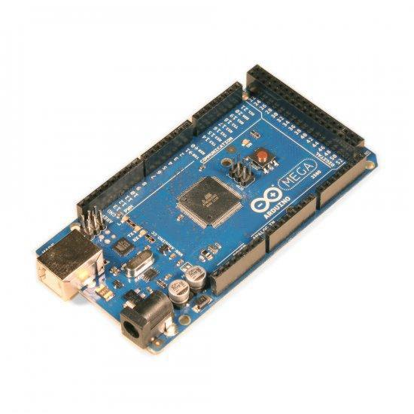**Arduino Mega2560 Rev3**

The Arduino Mega 2560 is a microcontroller board based on the ATmega2560. It has 54 digital input/output pins (of which 14 can be used as PWM outputs), 16 analog inputs, 4 UARTs (hardware serial ports), a 16 MHz crystal oscillator, a USB connection, a power jack, an ICSP header, and a reset button. It contains everything needed to support the microcontroller; simply connect it to a computer with a USB cable or power it with an AC-to-DC adapter or battery to get started. The Mega is compatible with most shields designed for the Arduino Uno, Duemilanove or Diecimila.

The Mega 2560 is an update to the Arduino Mega, which it replaces.

Additional features coming with the R3 version are:

* ATmega16U2 instead 8U2 as USB-to-Serial converter.
* 1.0 pinout: added SDA and SCL pins for TWI communication placed near to the AREF pin and two other new pins placed near to the RESET pin, the IOREF that allow the shields to adapt to the voltage provided from the board and the second one is a not connected pin, that is reserved for future purposes.
* stronger RESET circuit.

**Technical Specifications**

Microcontroller

Operating Voltage

Input Voltage (recommended)

Input Voltage (limits)

Digital I/O Pins

Analog Input Pins

DC Current per I/O Pin

DC Current for 3.3V Pin

Flash Memory

SRAM

EEPROM

Clock Speed

ATmega2560

5V

7-12V

6-20V

54 (of which 14 provide PWM output)

16

40 mA

50 mA

256 KB of which 8 KB used by bootloader

8 KB

4 KB

16 MHz

**Bluetooth module HC06**

Bluetooth modules are designed for wireless data transmission between small distances it Considered as wireless personal area network technology (WPAN) it works at ultra-high frequencies (UHF). Regarding to industrial, scientific and medical (ISM) radio bands witch governing industrial, scientific and medical frequencies, the Bluetooth range from 2.402 GHZ to 2.480.

It considers as the cheapest method for data transmission, easiest and more flexible compared to other methods. It even can transmit files reach to 25 Mb/s.

This technique depends on frequency hopping spread spectrum technique (FHSS) it use this technique to avoid interference with other devices and it a full duplex transmission which mean it can transmit and receive at same time.

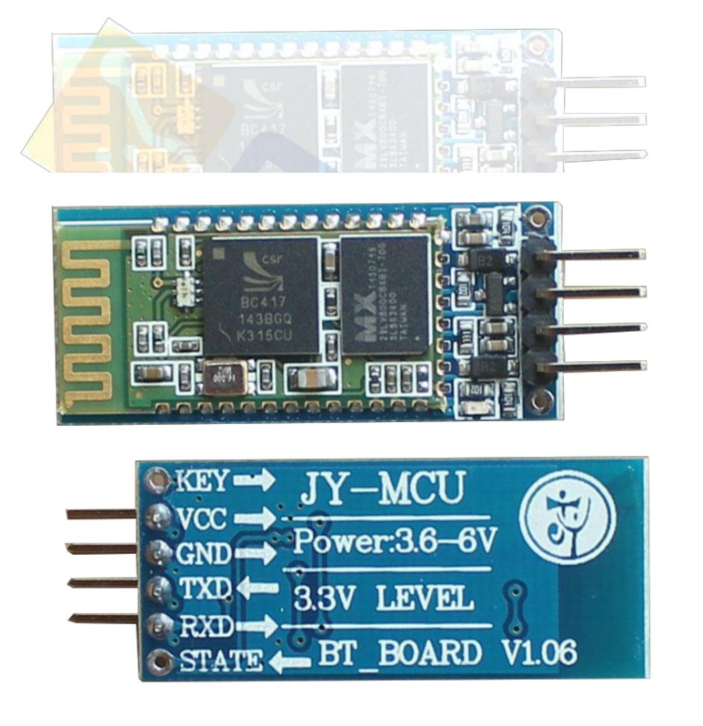

**Bluetooth module HC06 Features**

* Operating voltage: 5 v
* Slave: is a model for a communication protocol in which one device or process known as the master controls one or more other devices or processes known as slaves.
* Enable bin: it can be connected to 5V or left without connecting this allow the module to work but in case of connecting it to ground it doesn’t work.
* Key pin: some modules doesn’t contain this pin so a wire could be welded to it.

This pin has two modes AT mode which allow the user to enter commands to it and connection mode which allow the connection between device

**How Bluetooth connection occurs**

1- The master device sends request to all surrounding Bluetooth modules, all slave modules reply with the 48-bit number which is unique for each Bluetooth device similar to MAC address.

2- when the master determines the slave wants to pair with it starts synchronization process as the master send message with the internal date, time, type of the device, services provided by him and operating frequency these process occurred in base band layer.

3- after that the link manager layer in which Link Management Protocol (LMP) responsible for authentication and authorization process, data Encryption and frequency hopping management.

4- then in the next layer Logical Link Control and Adaptation Protocol (L2CAP) which responsible for data transmission management and data divide into packets.

5- using Service Discovery Protocol (SDP) the master Bluetooth module determines the service provided by the slave (profile) depending on this profile the master determines the type of data to send to this device.

6- finally the paring action occurs when the master device gives the pin number to allow the master to exchange data at any time.

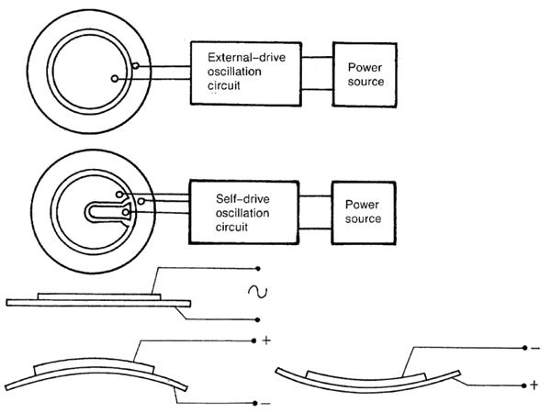**Piezo Transducer 30vac 0.5-20hz 75db lead type**

Tone type: piezo speaker

Operating voltage: 30 VAC

Rated voltage: 15 VAC

Current consumption: 1.5 mA

Resonant frequency: 0.5-20 ± 0.5 kHz

Sound pressure level: 75 dB

Connector type: leads

Body color: metal

Weight: 0.11 oz

**4x4 Matrix Membrane Keypad (#27899)**

This 16-button keypad provides a useful human interface component for microcontroller projects.

Convenient adhesive backing provides a simple way to mount the keypad in a variety of applications.

**Features**

* Ultra-thin Design
* Adhesive backing
* Excellent price/performance ratio
* Easy interface to any microcontroller
* Example programs provided for the BASIC Stamp 2 and Propeller P8X32A Microcontroller.

**Key Specification**

* Maximum Rating: 24 DCV, 30 mA
* Interface: 8-pin access to 4x4 matrix
* Operating temperature: 32 to 122 °F (0 to 50°C)
* Dimensions: Keypad, 2.7 x 3.0 in (6.9 x 7.6 cm) Cable: 0.78 x 3.5 in (2.0 x 8.8 cm).

**Application Ideas**

* Security systems
* Menu selection
* Data entry for embedded systems

**How it Works**

Matrix keypads use a combination of four rows and four columns to provide button states to the host device, typically a microcontroller. Underneath each key is a pushbutton, with one end connected to one row, and the other end connected to one column. These connections are shown in Figure 1.

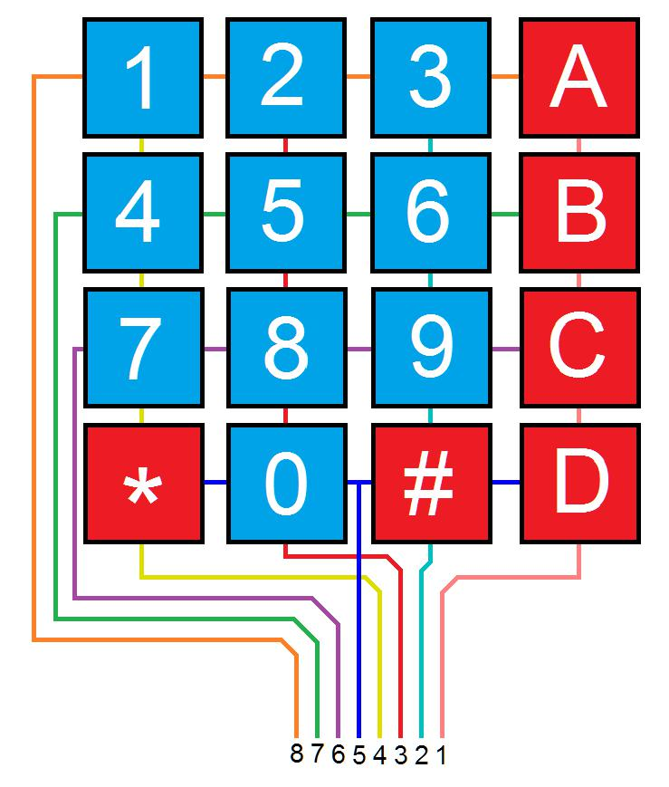

**Figure 1: Matrix Keypad Connections**

In order for the microcontroller to determine which button is pressed, it first needs to pull each of the four columns (pins 1-4) either low or high one at a time, and then poll the states of the four rows (pins 5-8). Depending on the states of the columns, the microcontroller can tell which button is pressed.

For example, say your program pulls all four columns low and then pulls the first row high. It then reads the input states of each column, and reads pin 1 high. This means that a contact has been made between column 4 and row 1, so button ‘A’ has been pressed.

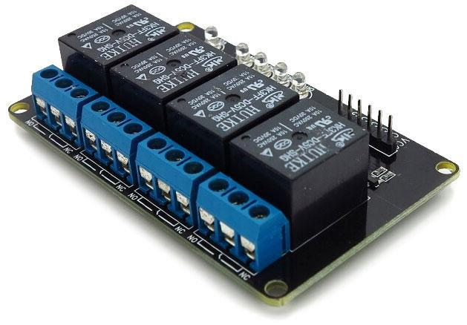**4-Channel 5V Relay Module**

**Description**

**Overview**

This is a 5V 4-Channels Relay module, It can be controlled directly by a wide range of microcontrollers such as Arduino, AVR, PIC, ARM and MSP430. 4 relays are included in this module, with “NC” ports means “Normally connected to COM” and “NO” ports means “Normally open to COM”. This module also equipped with 4 LEDS to show the status of relays.

**Features**

* 4 mechanical relays with status indicator LED
* Both “NC” and “NO” ports for each relay
* **Specification**
* Module Type: Control
* Weight: 70.00g
* Board Size: 8 x 4.8 x 2cm
* Version: 1
* Operation Level: Digital 5V
* Power Supply: External 5V

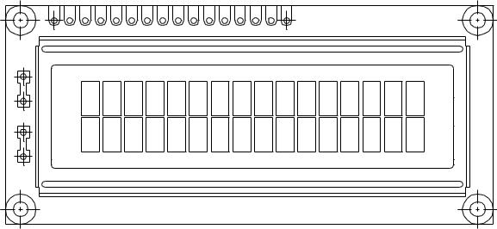**16 x 2 Character LCD**

**FEATURES**

* 5 x 8 dots with cursor
* Built-in controller (KS 0066 or Equivalent)
* + 5V power supply (Also available for + 3V)
* 1/16 duty cycle
* B/L to be driven by pin 1, pin 2 or pin 15, pin 16 or A.K (LED)
* N.V. optional for + 3V power supply

EDITOR CERTIFICATE

This is to certify that the thesis, entitled “**THESIS TITLE**,” submitted by **NAMES,** has been edited.

____________________________________

PROF.SHARON E. DELOS REYES, MACE

Editor